

Project Report

**Shopping Reimagined**

|  |
| --- |
| **Content** |

**Content**

1. Problem Definition 3
2. Requirements Analysis 7
3. Design phase 18
4. Architecture of Website 21
5. Evaluation/Testing 24
6. Project Tracking and Monitoring Activities 25
7. Documentation Section 26
8. Source Code 31
9. User Guide 44

|  |
| --- |
| 1. **Problem Definition** |

The Online Shopping is a web based application intended for online retailers. The main objective of this application is to make it interactive and its ease of use. It would make searching, viewing and selection of a product easier. It contains a sophisticated search engine for user's to search for products specific to their needs. The search engine provides an easy and convenient way to search for products where a user can Search for a product interactively and the search engine would refine the products available based on the user’s input. The user can then view the complete specification of each product. They can also view the product reviews and also write their own reviews. The application also provides a drag and drop feature so that a user can add a product to the shopping cart by dragging the item in to the shopping cart. The main emphasis lies in providing a user friendly search engine for effectively showing the desired results and its drag and drop behavior.

There are a lot of websites on internet whereby it offer a variety of product and services for consumer can find and buy through online such as shoe, apparel, sun glasses and more Moreover, the online also provides some of the services which is paying bill online, booking a transport ticket and more. In this research, we are looking the problem addressed in this research which is the view of [online shopping](https://www.bartleby.com/topics/online-shopping) by consumer.

However, there are several reason hinder in the consumer are involved in online shopping because some of the consumer are not willing to take part in online purchased due to the valid reason because there are worried about the quality of the product in online are not durable, moreover, there are not confident…

In addition, in this study also understand the influences of the social factors toward to purchase intention of consumers in online shopping and also study the attitude of the consumers purchase intention in online shopping.

**Problem:**

* Customer can browser through the product catalog and add the items to shopping cart. He can proceed to checkout as long as his shopping cart is not empty. Customer will require to login to the system when he proceed to checkout, or he can create an account if he not yet have one. The order will charge to the credit card registered in customer's account. Customer need to provides full name, email address, phone number, credit card and billing address details when creating an account.
* Customer can login to the system to maintain his account information, such as changing phone number, address, and credit card details, and check the status of his orders. Upon order received, the sales staff will process the order by charge to customer's credit card. Once the order has been charged, he will then mark the order as paid and pass to courier company and deliver them to customer. If the items customer ordered is out of stock, then the order will mark as on hold. Once the item(s) arrived, the order will pass to courier company for delivery. Courier company will pack the item with standard packaging, but if the order is marked as gift, then the items will pack as gift. If the items arrived with damage, customer can return it by register in the online shop. Courier company will collect the item from customer and sales staff will refund the money for that item. Marketing staff responsible to maintain the product catalog. He can also setup the promotion item list and send promotion email to customer.
* The basic problems with the existing systems are the non-interactive environment they provide to the users.
* The use of traditional user interfaces which make continuous post backs to the server; each post back makes a call to the server, gets the response and then refreshes the entire web form to display the result. This scenario adds an extra trade off causing a delay in displaying the results
* A search engine that would display the results without allowing the users to further filter the results based on various parameters.
* Use of traditional and non user friendly interfaces that are hard to use

Customer:

* Can use keywords to find out what products you need.
* Can comment/feedback for products/website/webmaster.

**Solution:**

* The motive of this Online Shopping Web Application is to allow the user to play with the search tool and create different combinatorial search criterion to perform exhaustive search.
* Making the application AJAX enabled gets rid of these unnecessary delays letting the user to perform exhaustive search. The users of this application can easily feel the difference between the Ajax empowered user interfaces vs. traditional user interfaces.
* Provide Interactive interface through which a user can interact with different areas of application easily.
* A search engine that provides an easy and convenient way to search for products specific to their needs. The search engine would list a set of products based on the search term and the user can further filter the list based on various parameters.
* Provide Drag and Drop feature thereby allowing the user to add products to or remove products from the shopping cart by dragging the products in to or out of the shopping cart.

2. Requirements Analysis

**OUTPUT INFORMATION**

**PROCESS**

**INPUT DATA**

Input:

* Input member registration information.
* Input the product name customer are looking for.
* Comments/feedback for administration.
* Read information from JSon/Text data Store.

Process:

* Check member registration information.
* Find the product name customer are looking for.
* Check comments/feedback for administration.
* Check information from JSon/Text data Store.

Output:

* Notification of successful / failed registration.
* Notification on a screen with or without the product the customer is looking for.
* Notification of successful/failed for comments/feedback.
* Notification information to JSon/Text data Store.

Web master:

Input:

- Input a username password when an administrator login to admin web.

- Input information about the product to add / edit / delete.

- Enter information about the brand to add / edit / delete.

- Respond to customer comments/feedback.

Process:

* The product to add / edit / delete.
* The brand to add / edit / delete.
* Check information for replies of comment/feedback.
* Delete comment/feedback.

Output:

* Login success / failure notification.
* Notice of successful / failed product deletion.
* Notice of successful / failed brand deletion.
* Notice of successfully / failed replies for comment/feedback.
* Notice of successfully / failed deletion for comment/feedback.

**Hardware/ Software Requirements:**

**Hardware:**

* Intel Core i3/i5 Processor or higher
* 8 GB RAM or above
* Color SVGA
* 500 GB Hard Disk space
* Mouse
* Keboard

**Software:**

* Frontend: HTML5, CSS3, Bootstrap , JavaScript, jQuery, AngularJS, Angular9 (optional), XML
* Data Store: JSON/Text

**Scope of the work:**

Shopping Reimagined is an online shopping, here are some categories of the website:

* Homepage for Shopping Reimagined ortal that will further display menu options for Homepage, Products, Search, Support, About Us, Feedback, Account, Shopping Cart and Notification.
* Register/Login/Logout will lead to appropriate pages where users can register themselves, login or logout if already registered.
* The Products menu when clicked will display all products we sales and some logos of various companies each of which will have a hyperlink. Clicking the hyperlink will lead to the company information and its ad rates.
* About Us and Contact Us should contain some relevant information.
* The user can view and visit the links of their favorite brands or companies.

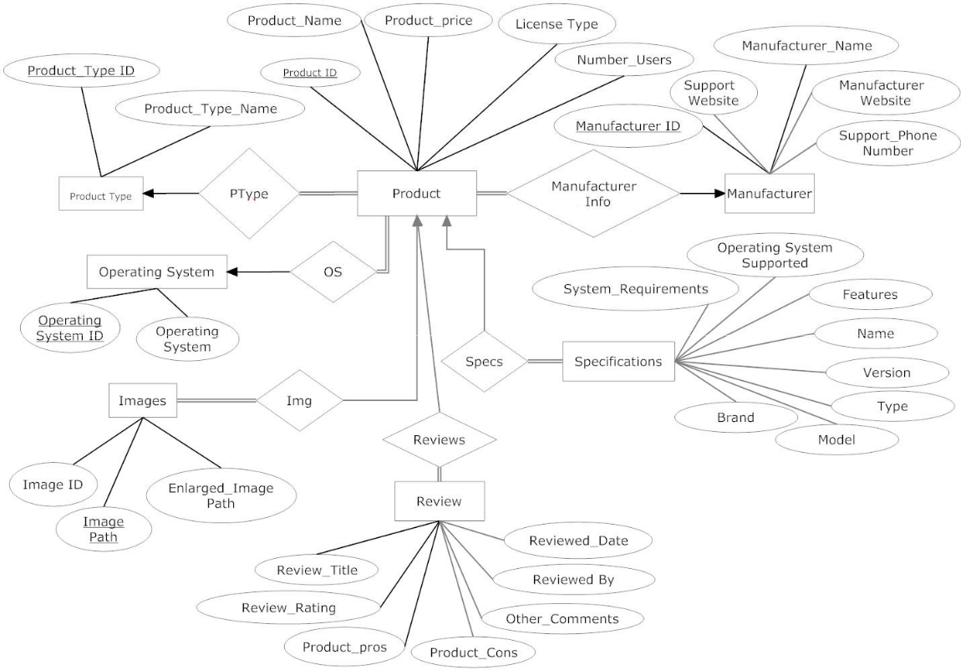***2.1 ER Diagram***

2.2 **Data Flow Diagram**

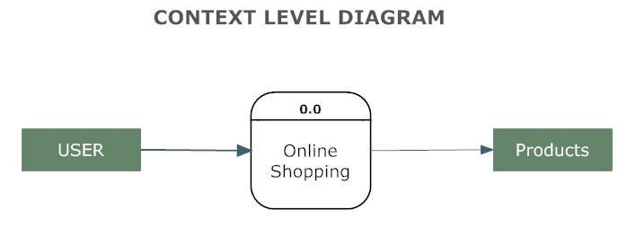

**2.2.1 A First Level Diagram**

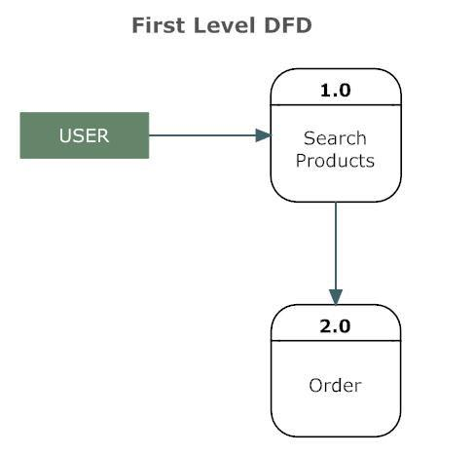

**2.2.2 A Second Level Diagram**

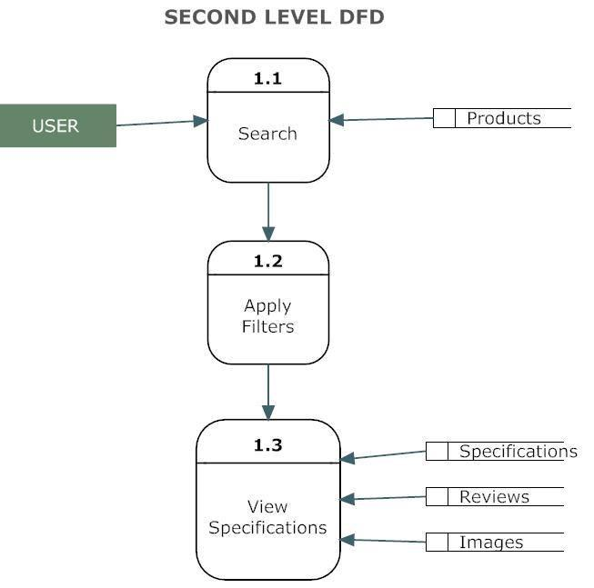

**2.2.3 A Second Level Diagram**

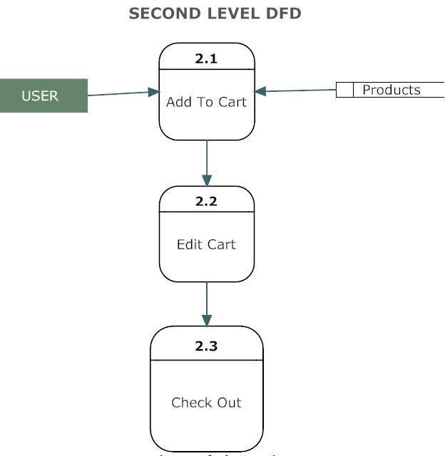

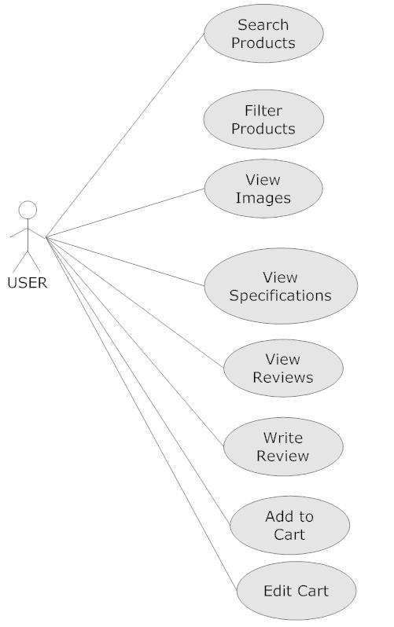2.3.4 **Use Case Diagram**

2.4 **Class Diagram**

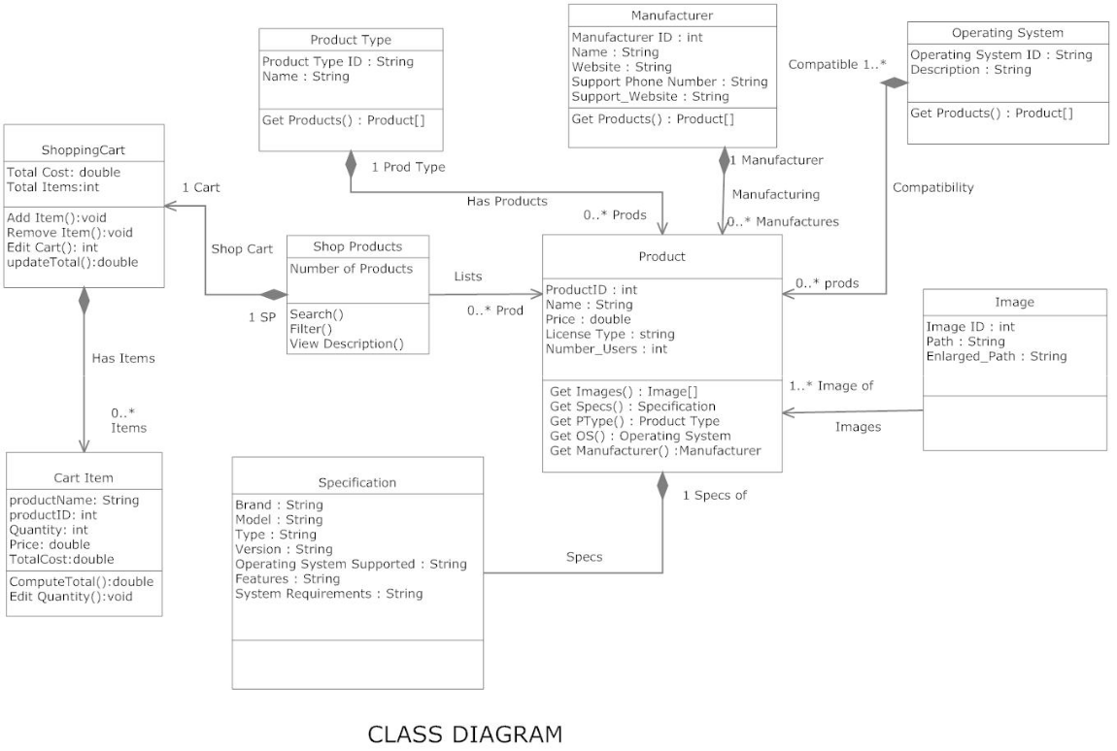

|  |  |
| --- | --- |
| **S.No.** | **Customer’s Acceptance Criteria** |
| 1. | Behaivior: Observable behavior of a system or tool that can be tested by using it. OX For example, "a user is able to view a complete history of their orders. |
| 2. | Business Rules: Business rules are often phrased as if ... then statements. For example, "if the user gets their password wrong three times then they are locked out of the system for 30 minutes." |
| 3. | Process Flow: Specifications of steps in a process including automated steps and ent human tasks. For example, "when the customer submits an application an approval task is created in the sales system." |
| 4. | Calculations: Specifications for a calculation that may include business rules, algorithms and formulas. For example, "if the customer account is less than one year old, 10 points is added to the risk score." |
| 5. | Events: Details of how events are generated and handled. For example, "if a customer doesn't purchase an item within 10 minutes of adding it to their cart, the marketing system is notified.” |
| 6. | Validations: Details of how events are generated and handled. For example, "if a customer doesn't purchase an item within 10 minutes of adding it to their cart, the marketing system is notified." Validations Validation of user input. For example, "if the customer adds a product to their cart that can't be shipped to their default shipping location, present a warning message that states ..." |
| 7. | Usability: Capturing aspects of a product that make it pleasing and productive to use. For example, "by default, all sounds are disabled." |
| 8. | Look & Feel: Expectations for look and feel that give designers enough flexibility to make things look good. For example, "the site is compliant with our brand style guide." |
| 9. | Implementation: Expectations for implementation that give architects, designers, engineers, subject matter experts and other implementors flexibility to do their job. For example, "the software will pass security review and testing processes as defined by the Chief Information Security Officer." |
| 10. | Performance: Performance requirements such as "the system will have a page load time of less than 3 seconds with 1000 concurrent users." |
| 11 | Controls: Definitions of internal controls. For example, "the system will log all requests with a user id." |
| 12. | Operations: Operations requirements such as "the platform will integrate with the auto scaling API and automatically request resources as required to handle workloads." |
| 13. | Quality: Expectations for quality such as "the device will continue to operate normally after being dropped 22 times from a height of 6 feet onto concrete." |
| 14. | Materials: Constraints on materials such as "all ingredients will be certified organic." |

|  |
| --- |
| **3.Design Phase** |

* **Designing the GUI Standards**- The design of the web application involves the design of the forms for listing the products, search for products, display the complete specification for the product, and design a shopping cart that is easy to use.
* Design of an interactive application that enables the user to filter the products based on different parameters.
* Design of an application that has features like drag and drop etc.
* Design of application that decreases data transfers between the client and the server.
* For the Shopping Reimagined portal, multiple screens must be created and linked to each other. Each of these screens should have a consistent look with respect to appearance, and theme used. The font styles, color of the labels, design and appearance of the command buttons, the appearance of header and footer, and the design and size of controls, such as check boxes or text boxes should be consistent through all the forms.  
  In the case of Shopping Reimagined portal, the modules could be for:  
   + Registration  
   + Login  
   + Feedback

+ Contact us

**Document Design:**

|  |  |
| --- | --- |
| **Property** | **Value** |
| Document Theme and Color Scheme | Orange-white-black |
| Form-Background Color | Orange-white-black |
| Title-Font Size | San-serif |
| Title-Font Color | Orange-white-black |
| Title-Font Style | Normal, bold, italic |
| Title-Alignment | Center-left-right |
| Background color of Controls on the form | Orange |
| Foreground color of Controls on the form | OK |
| Control Caption-  Font Size | 14-16px |
| Control Caption- Font Color | 16px |
| Control Caption- Font Style | 16px |
| Control caption and controls-Alignment | Center-left-right |
| Command button-Alignment | Center-left-right |

* **Final checklist:**

|  |  |  |
| --- | --- | --- |
| **Sr.No** | **Aspected Tested** | **Suggestion/**  **Remarks** |
| 1 | Are all the users able to view the images and links? | Ok |
| 2 | Have all the views, modules and controllers been properly integrated and is the site function as a single page application? | Ok |
| 3 | Are the GUI content devoid of spelling mistakes? | Ok |
| 4 | Is the application user-friendly? | Ok |
| 5 | Is the Website launching correctly in all popular browsers? | Ok |
| 6 | Are all the forms validated with proper criteria? | Ok |
| 7 | Do all text links lead to the appropriate website? | Ok |
| 8 | Do all image links lead to the appropriate website? | Ok |
| 9 | Are all the images and links clearly visible on the page? | Ok |
| 10 | Does the Web page work properly in all the tested browsers? | Ok |
| 11 | Does the Web page take too long to be loaded fully? | Ok |
| 12 | Is the navigation sequences correct through all the Web pages on the site? | Ok |
| 13 | Is the JavaScript code working as expected in all click events? | Ok |
| 14 | Is there a spot where they get stuck and find your website difficult to use? | Ok |
| 15 | Are there any actions that they find confusing? | Ok |
| 16 | Is the font size hard to read? | Ok |
| 17 | Are pop-ups annoying and obtrusive? | Ok |
| 18 | Is the website easy to use on a desktop, tablet and mobile device? | Ok |

|  |
| --- |
| **4.Architecture of Website** |

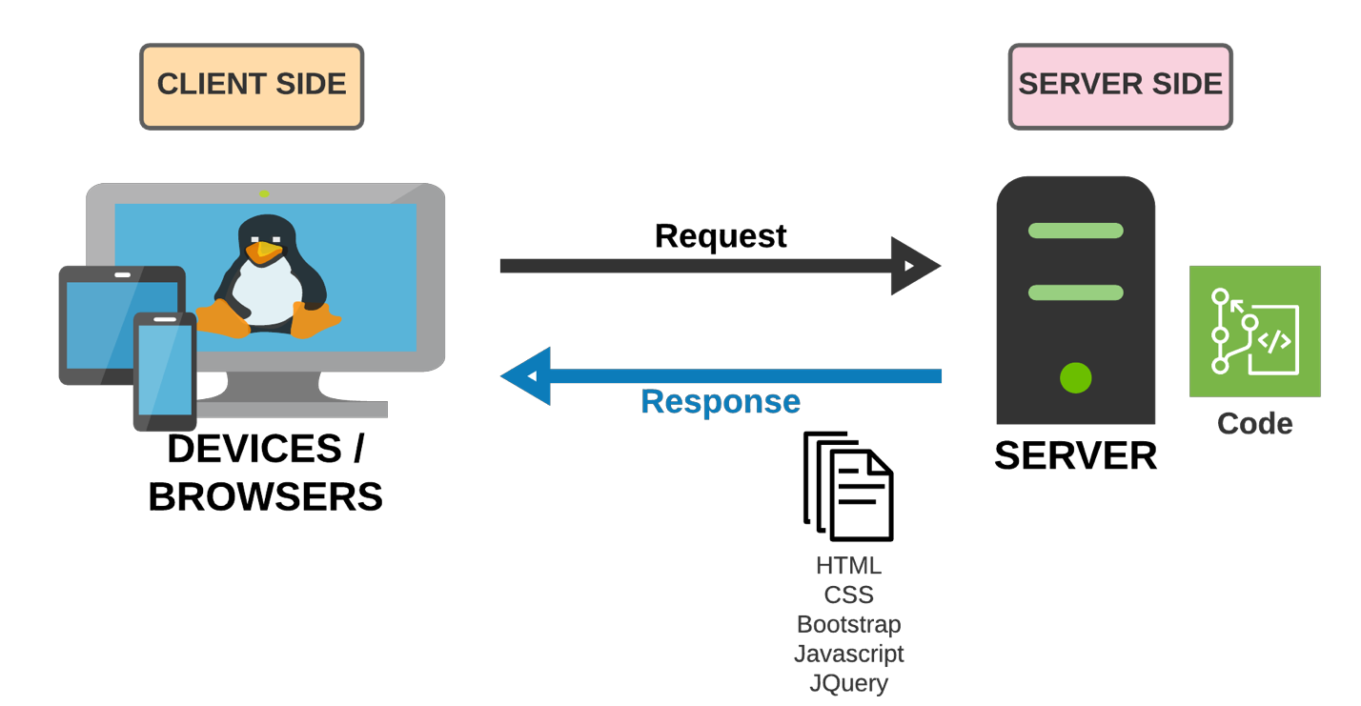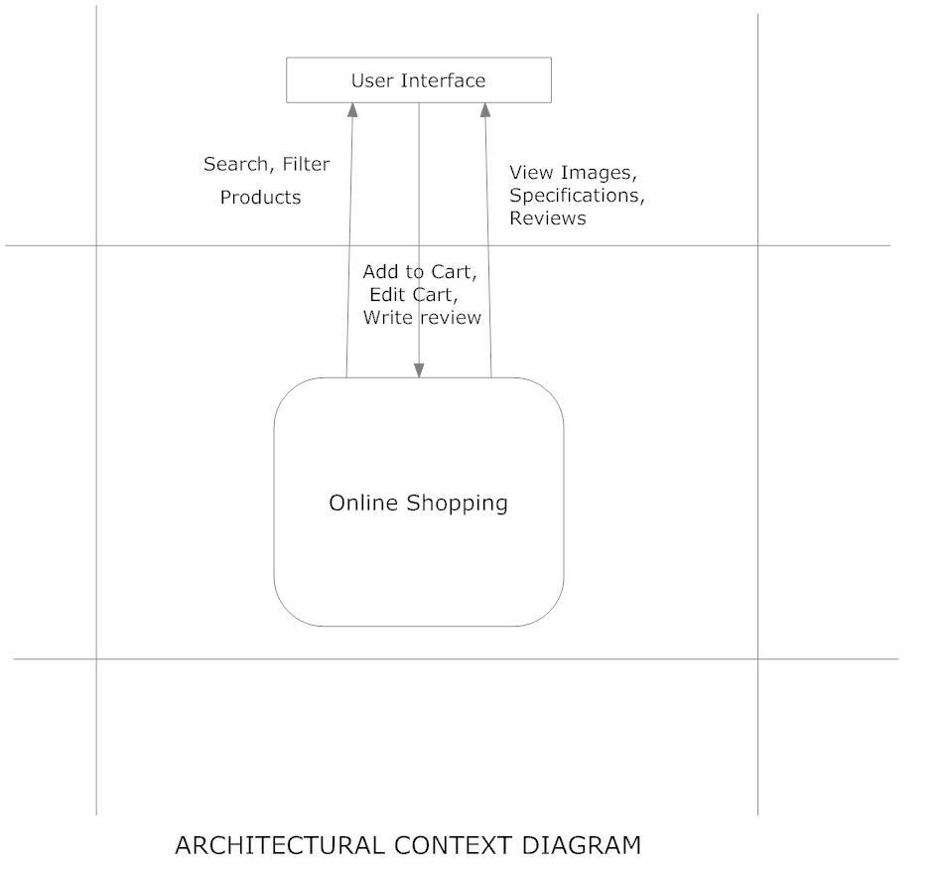

**Site Map**

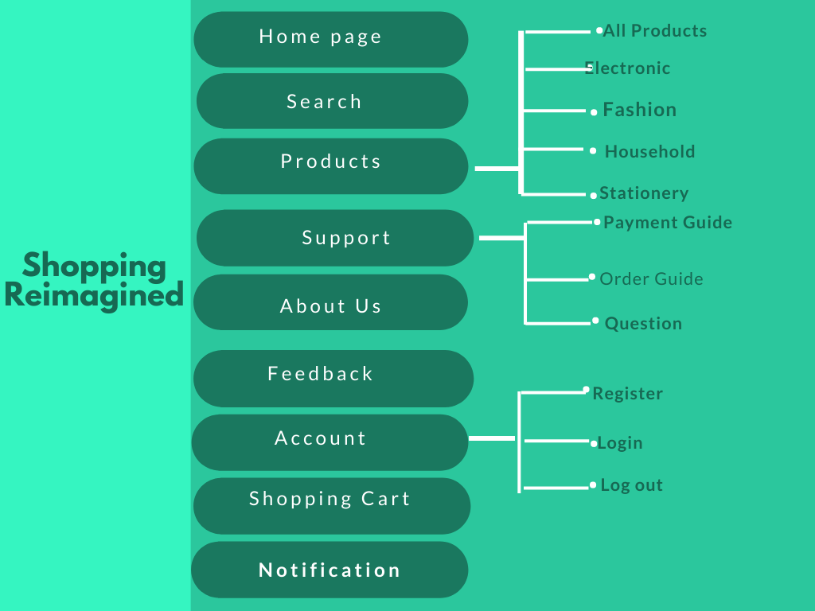

|  |
| --- |
| **5.Evaluation/Testing** |

|  |  |  |
| --- | --- | --- |
| **Sr.No** | **Testing Menu** | **Suggestion/**  **Remarks** |
| 1 | Homepage | Ok |
| 2 | Products | Ok |
| 3 | Search | Ok |
| 4 | Supports | Ok |
| 5 | About Us | Ok |
| 6 | FeedBack | Ok |
| 7 | Account | Ok |
| 8 | Shopping Cart | Ok |
| 9 | Notification | Ok |

|  |  |  |
| --- | --- | --- |
| **Sr.No** | **Testing Links** | **Suggestion/**  **Remarks** |
| 1 | All product | Ok |
| 2 | Electronic | Ok |
| 3 | House Hold | Ok |
| 4 | Fashion | Ok |
| 5 | Stationery | Ok |
| 6 | Payment Guide | Ok |
| 7 | Order Guide | Ok |
| 8 | Question | Ok |
| 9 | Register | Ok |
| 10 | Login | Ok |
| 11 | Logout | Ok |
| **6.Project Tracking And Monitoring Activities** | | |

|  |  |  |  |  |  |
| --- | --- | --- | --- | --- | --- |
| **Date:** | **Project Plan/ Milestone** | **Work Specification** | **Status of the Activity** | **Remarks** | **Responsibility** |
| 24/04/2021 | Design template for pages. | Finished design template for pages. |  | Ok | All teams |
| 25/04/2021 | Detailed design for the pages. | Finished detail design for the pages. |  | Ok | All teams |
| 26/04/2021 | Finished website and write documentation | Finished website  Write Documentation |  | Ok  Ok | All teams  Nguyen Ngoc Son |

|  |
| --- |
| **7.Documentation Section** |

|  |  |  |
| --- | --- | --- |
| **Sr.No** | **Testing Menu** | **Suggestion/**  **Remarks** |
| 1 | Homepage | Ok |
| 2 | Products | Ok |
| 3 | Search | Ok |
| 4 | Supports | Ok |
| 5 | About Us | Ok |
| 6 | FeedBack | Ok |
| 7 | Account | Ok |
| 8 | Shopping Cart | Ok |
| 9 | Notification | Ok |

|  |  |
| --- | --- |
| **S.No.** | **Customer’s Acceptance Criteria** |
| 1. | Behaivior: Observable behavior of a system or tool that can be tested by using it. OX For example, "a user is able to view a complete history of their orders. |
| 2. | Business Rules: Business rules are often phrased as if ... then statements. For example, "if the user gets their password wrong three times then they are locked out of the system for 30 minutes." |
| 3. | Process Flow: Specifications of steps in a process including automated steps and ent human tasks. For example, "when the customer submits an application an approval task is created in the sales system." |
| 4. | Calculations: Specifications for a calculation that may include business rules, algorithms and formulas. For example, "if the customer account is less than one year old, 10 points is added to the risk score." |
| 5. | Events: Details of how events are generated and handled. For example, "if a customer doesn't purchase an item within 10 minutes of adding it to their cart, the marketing system is notified.” |
| 6. | Validations: Details of how events are generated and handled. For example, "if a customer doesn't purchase an item within 10 minutes of adding it to their cart, the marketing system is notified." Validations Validation of user input. For example, "if the customer adds a product to their cart that can't be shipped to their default shipping location, present a warning message that states ..." |
| 7. | Usability: Capturing aspects of a product that make it pleasing and productive to use. For example, "by default, all sounds are disabled." |
| 8. | Look & Feel: Expectations for look and feel that give designers enough flexibility to make things look good. For example, "the site is compliant with our brand style guide." |
| 9. | Implementation: Expectations for implementation that give architects, designers, engineers, subject matter experts and other implementors flexibility to do their job. For example, "the software will pass security review and testing processes as defined by the Chief Information Security Officer." |
| 10. | Performance: Performance requirements such as "the system will have a page load time of less than 3 seconds with 1000 concurrent users." |
| 11 | Controls: Definitions of internal controls. For example, "the system will log all requests with a user id." |

|  |  |  |
| --- | --- | --- |
| **Sr.No** | **Aspected Tested** | **Suggestion/**  **Remarks** |
| 1 | Are all the users able to view the images and links? | Ok |
| 2 | Have all the views, modules and controllers been properly integrated and is the site function as a single page application? | Ok |
| 3 | Are the GUI content devoid of spelling mistakes? | Ok |
| 4 | Is the application user-friendly? | Ok |
| 5 | Is the Website launching correctly in all popular browsers? | Ok |
| 6 | Are all the forms validated with proper criteria? | Ok |
| 7 | Do all text links lead to the appropriate website? | Ok |
| 8 | Do all image links lead to the appropriate website? | Ok |
| 9 | Are all the images and links clearly visible on the page? | Ok |
| 10 | Does the Web page work properly in all the tested browsers? | Ok |
| 11 | Does the Web page take too long to be loaded fully? | Ok |
| 12 | Is the navigation sequences correct through all the Web pages on the site? | Ok |
| 13 | Is the JavaScript code working as expected in all click events? | Ok |
| 14 | Is there a spot where they get stuck and find your website difficult to use? | Ok |
| 15 | Are there any actions that they find confusing? | Ok |
| 16 | Is the font size hard to read? | Ok |
| 17 | Are pop-ups annoying and obtrusive? | Ok |
| 18 | Is the website easy to use on a desktop, tablet and mobile device? | Ok |

|  |  |  |  |  |  |  |  |
| --- | --- | --- | --- | --- | --- | --- | --- |
| **Property** | | | | | | **Value** | |
| Document Theme and Color Scheme | | | | | | OK | |
| Form-Background Color | | | | | | OK | |
| Title-Font Size | | | | | | OK | |
| Title-Font Color | | | | | | OK | |
| Title-Font Style | | | | | | OK | |
| Title-Alignment | | | | | | OK | |
| Background color of Controls on the form | | | | | | OK | |
| Foreground color of Controls on the form | | | | | | OK | |
| Control Caption- Font Size | | | | | | OK | |
| Control Caption- Font Color | | | | | | OK | |
| Control Caption- Font Style | | | | | | OK | |
| Control caption and controls-Alignment | | | | | | OK | |
| Command button-Alignment | | | | | | OK | |
| **Date:** | **Project Plan/ Milestone** | **Work Specification** | **Status of the Activity** | **Remarks** | **Responsibility** | |
| 24/04/2021 | Design template for pages. | Finished design template for pages. |  | Ok | All teams | |
| 25/04/2021 | Detailed design for the pages. | Finished detail design for the pages. |  | Ok | All teams | |
| 26/04/2021 | Finished website and write documentation | Finished website  Write Documentation |  | Ok  Ok | All teams  Nguyen Ngoc Son | |

|  |
| --- |
| **8.Source Code** |

1. HomePage

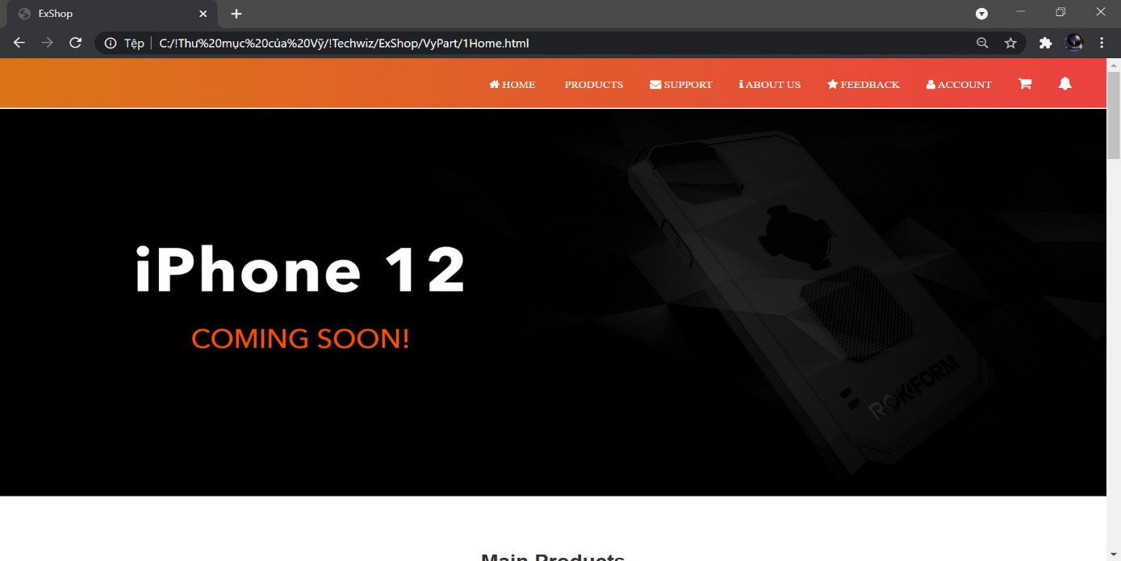

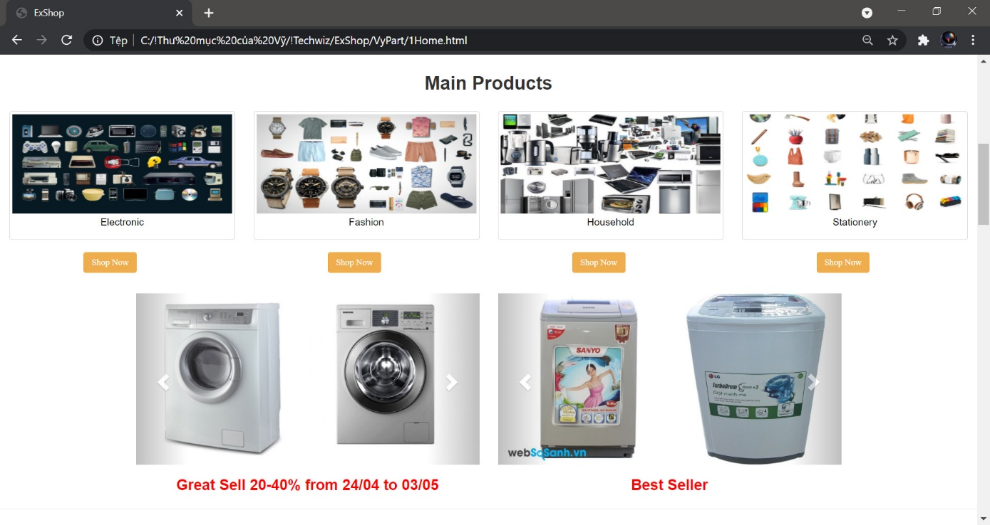

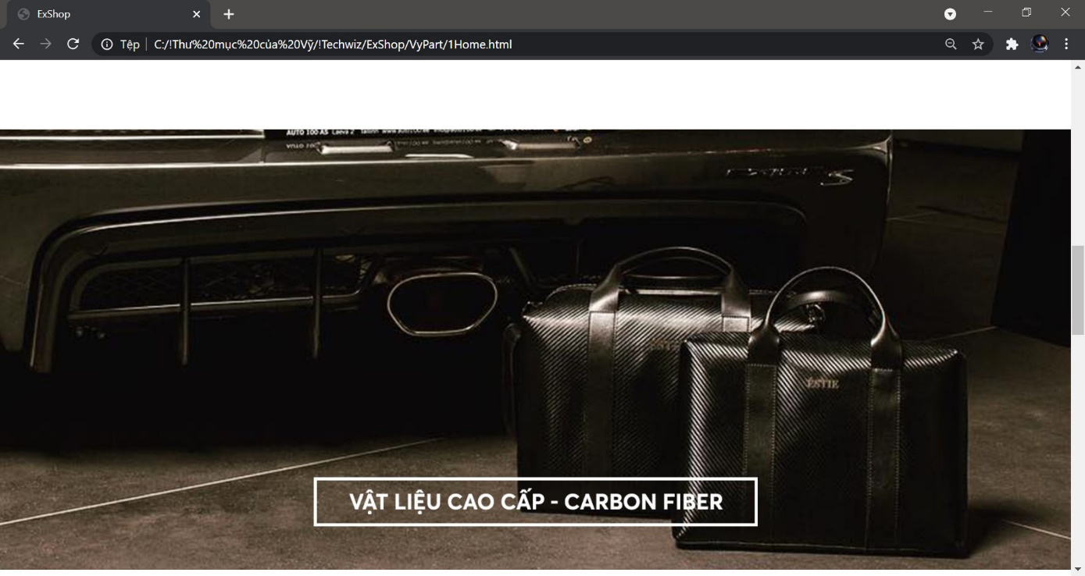

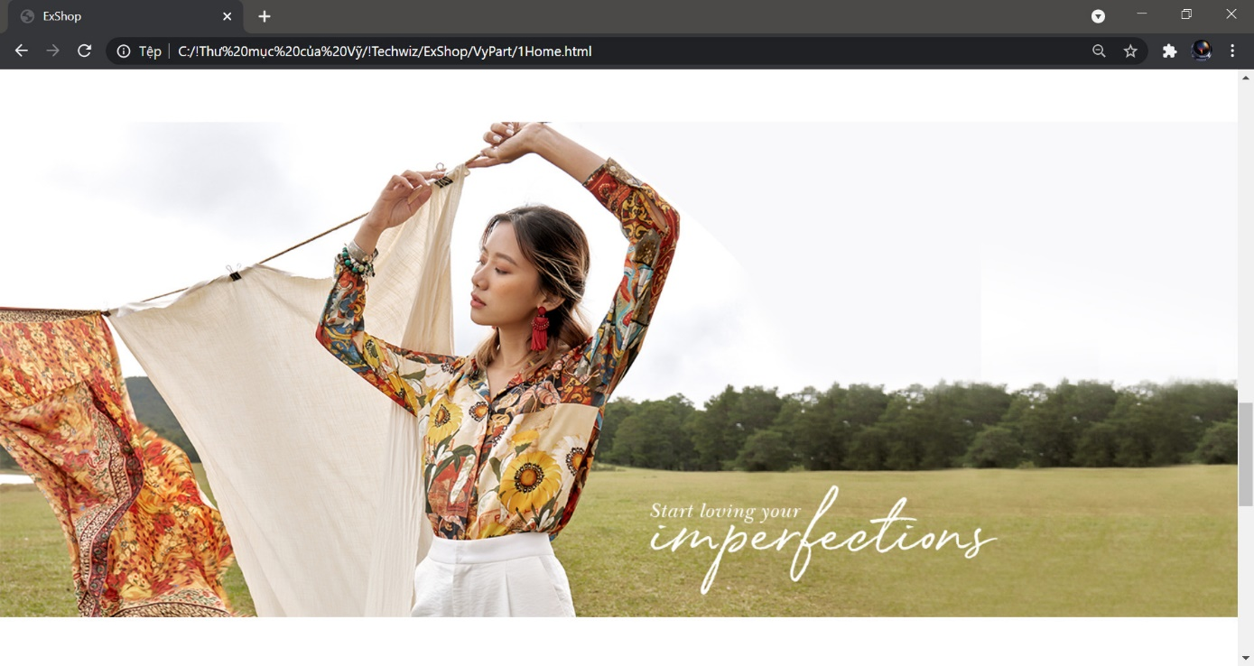

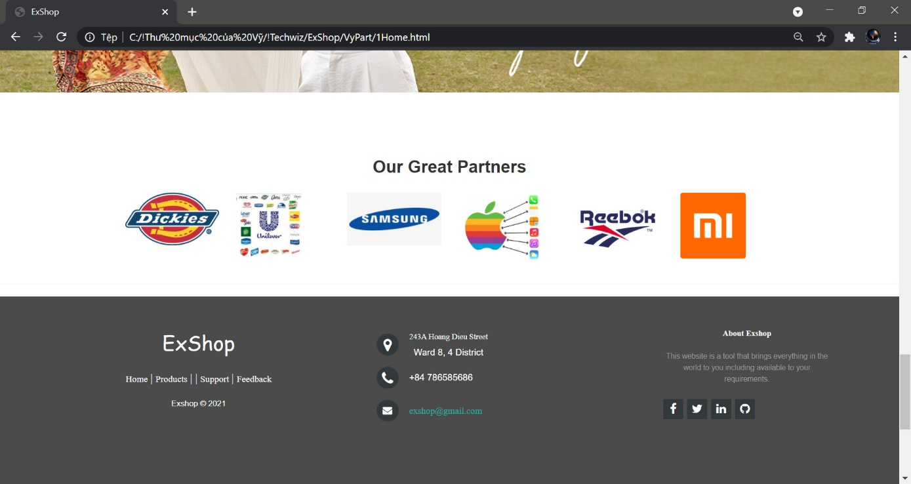

Code:

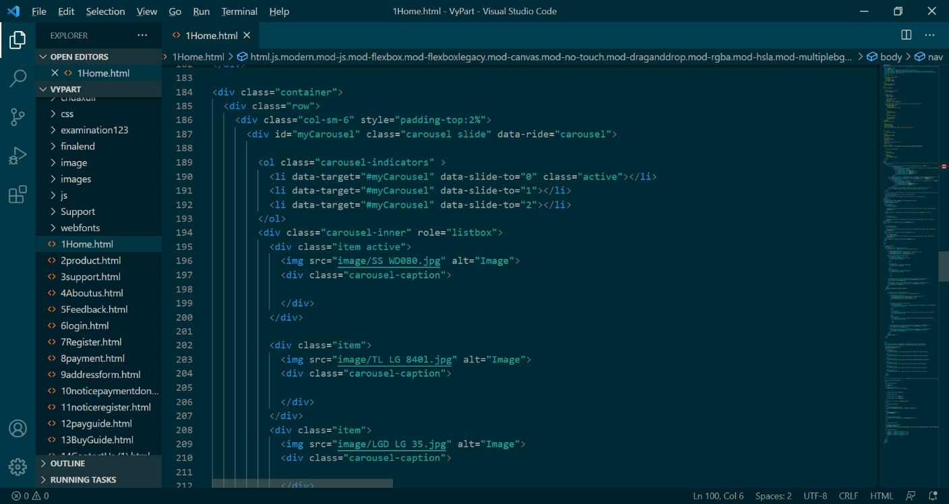

1. Search

Here you can directly find the product you are looking for.

1. Products

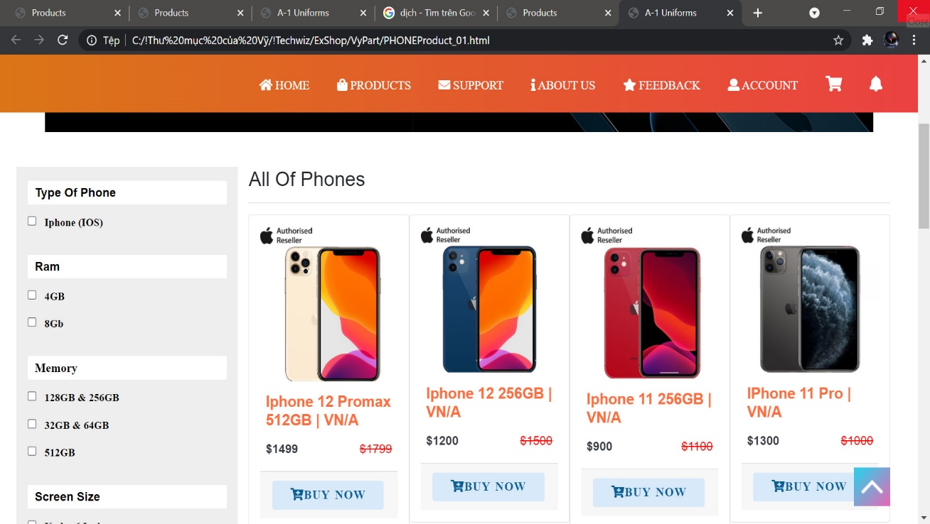

Code:

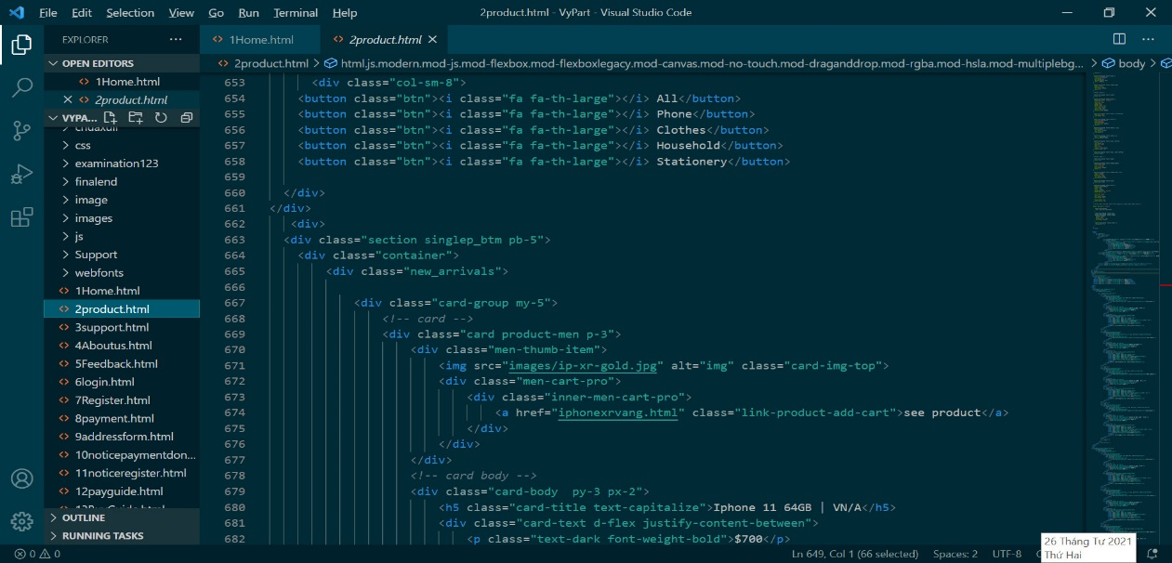

This is products page of website, in here you can see all of our products includes: Electronic, Household, Fashion and Stationery

1. Supports

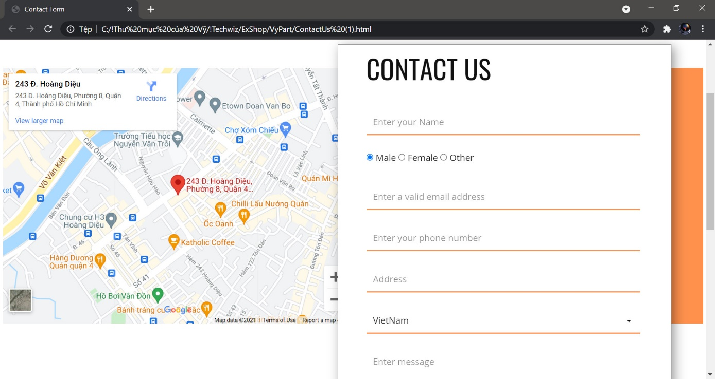

This is contact us page, in here you can contact with our website master what do you want?

1. Feedback

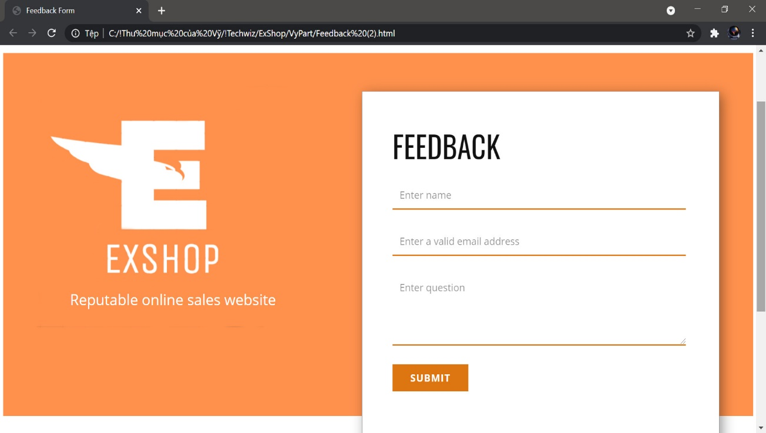

This is feedback page. In here you can send to us about some feedback/comments.

1. About us

In here, we introduce about us.

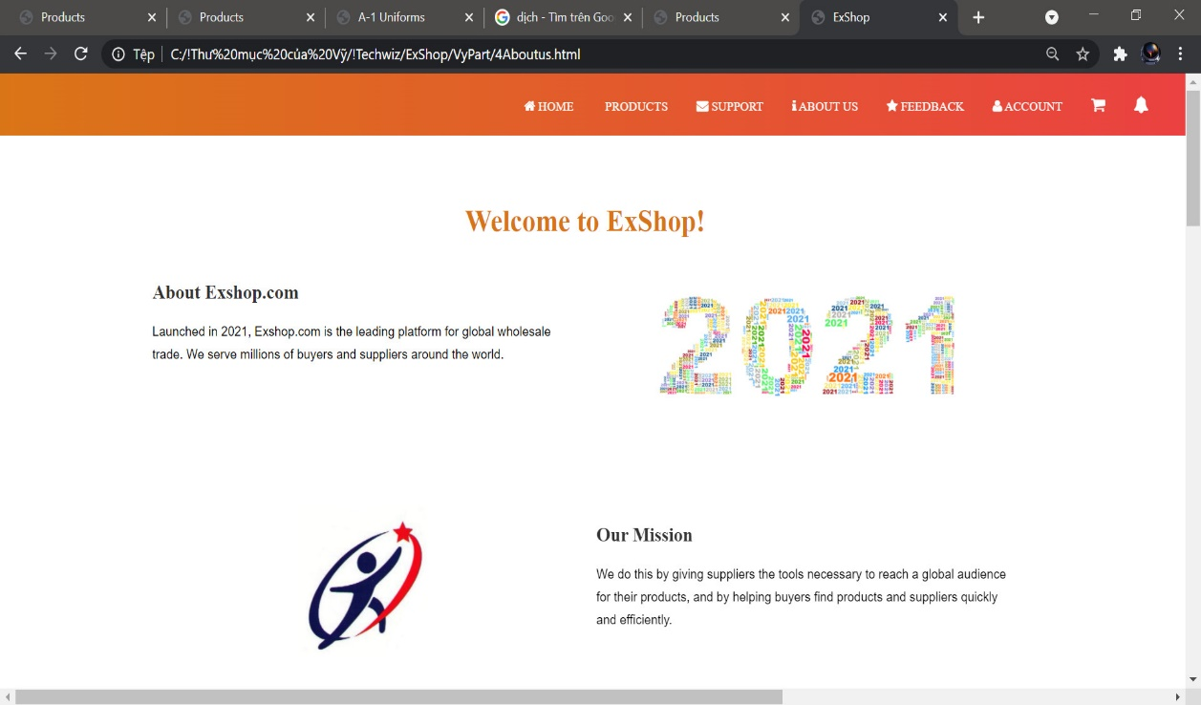

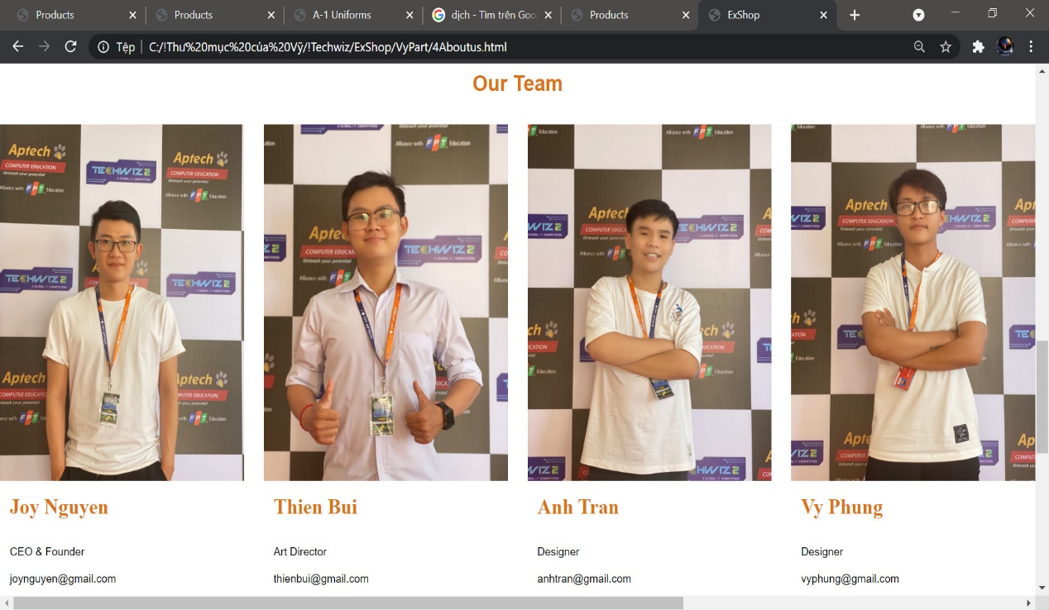

1. Account

In here you can:

* Register: if you don’t have account and want to be our website membership.
* Login: if you had account.
* Logout: if you want leave this website.

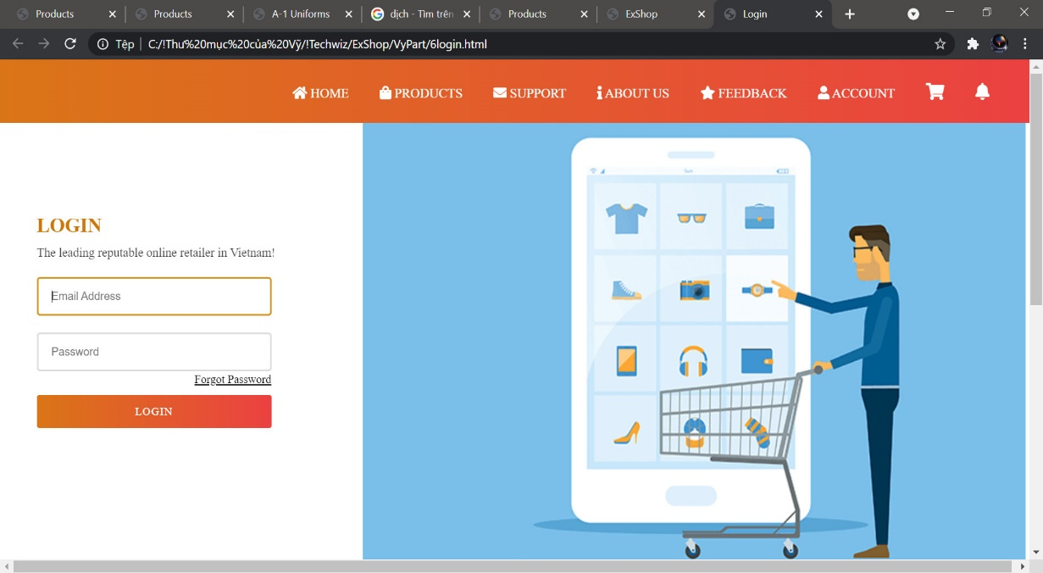

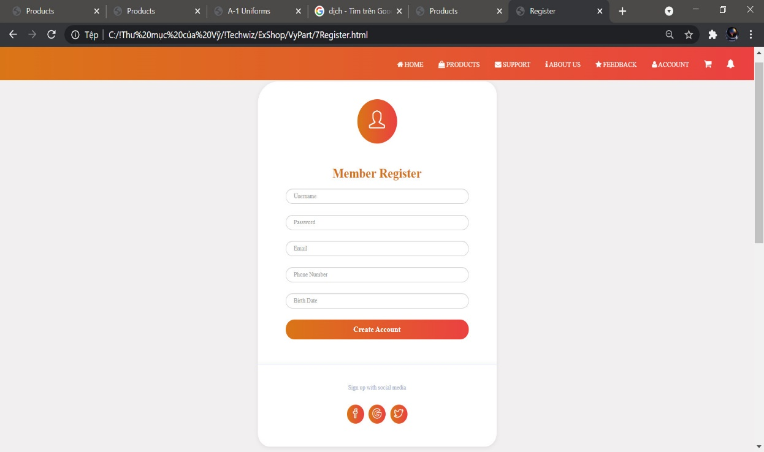

1. Shopping cart

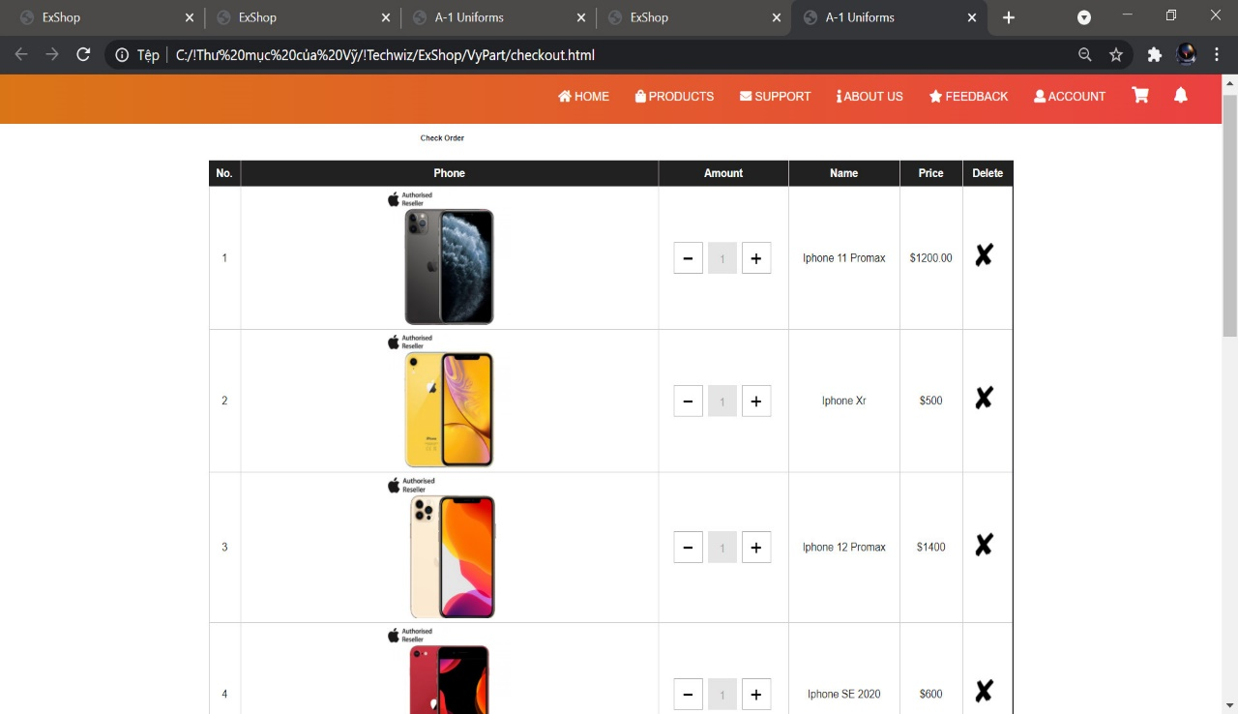

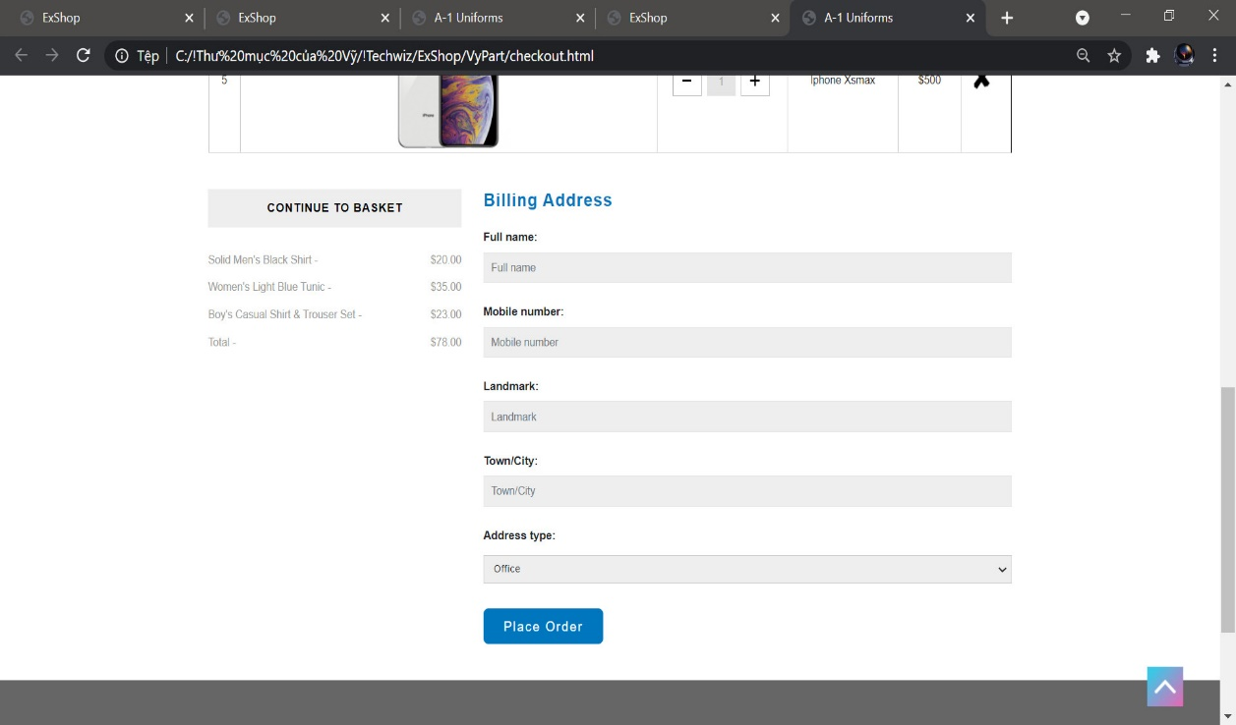

In here you can see all of products you choose.

And then you can go to payment page to here

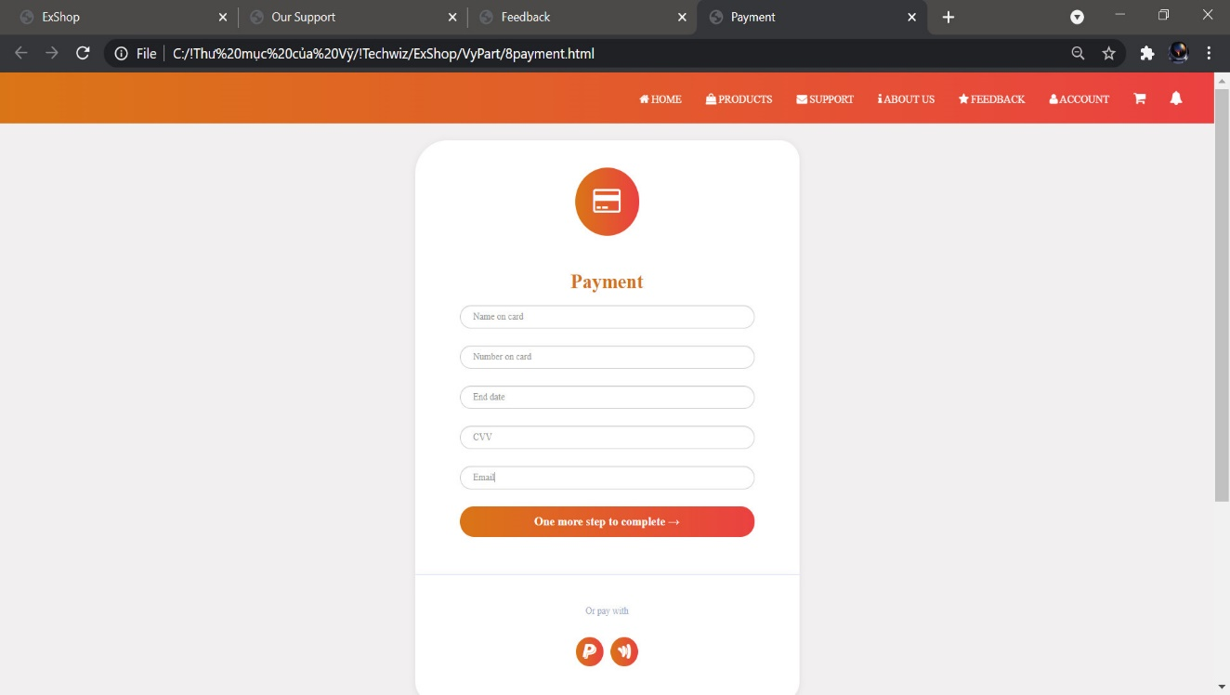

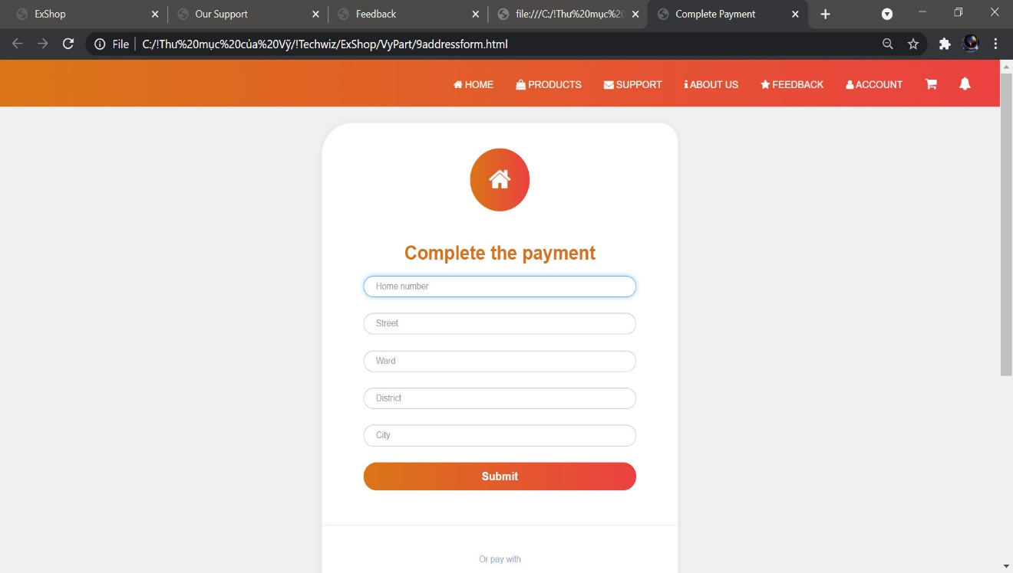

Code:

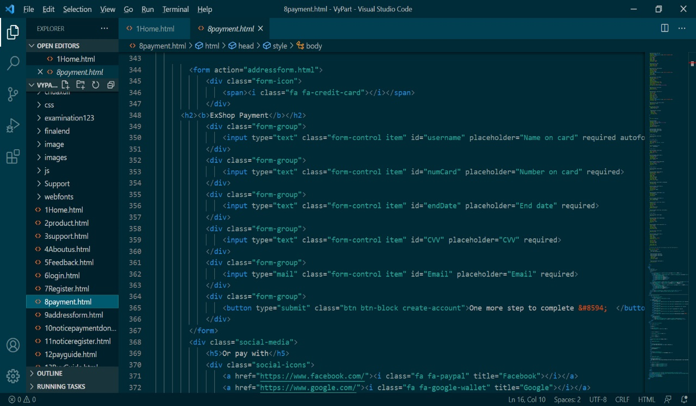

1. Notification

In here you can see and read all of notification of your account.

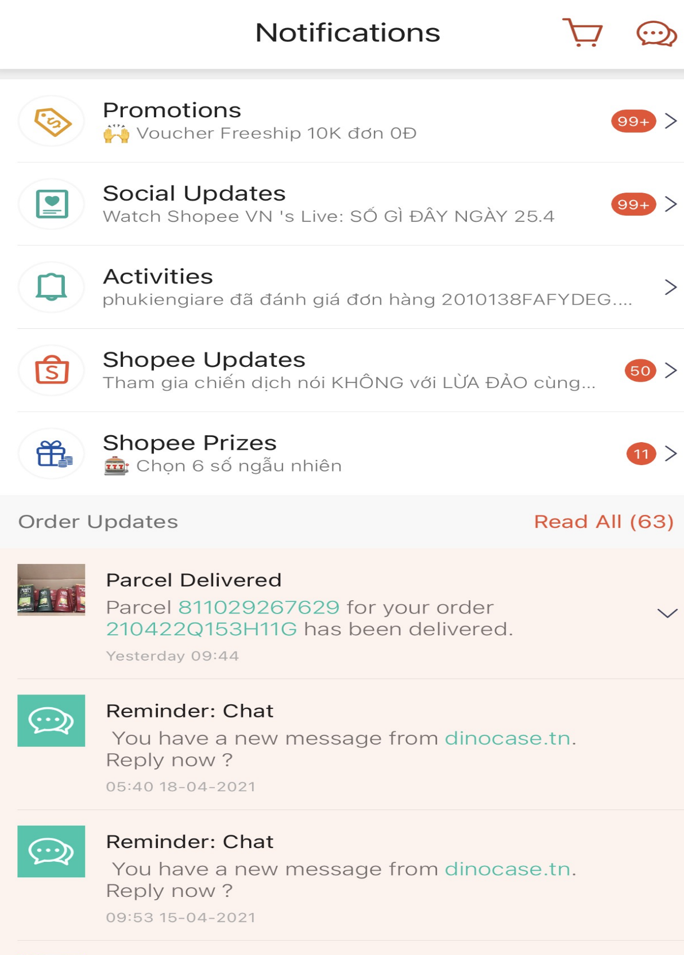

|  |
| --- |
| User Guide |

This section contain information about each page in the website:  
1. Home page



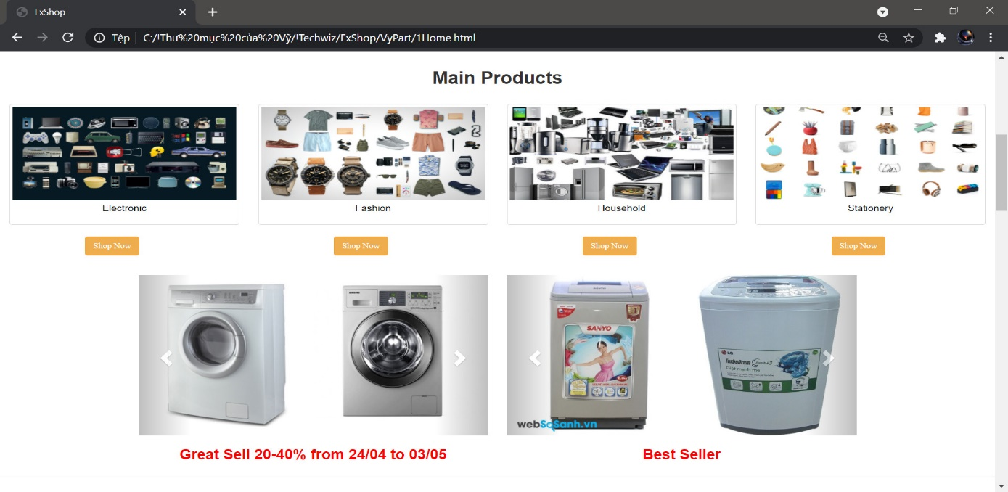

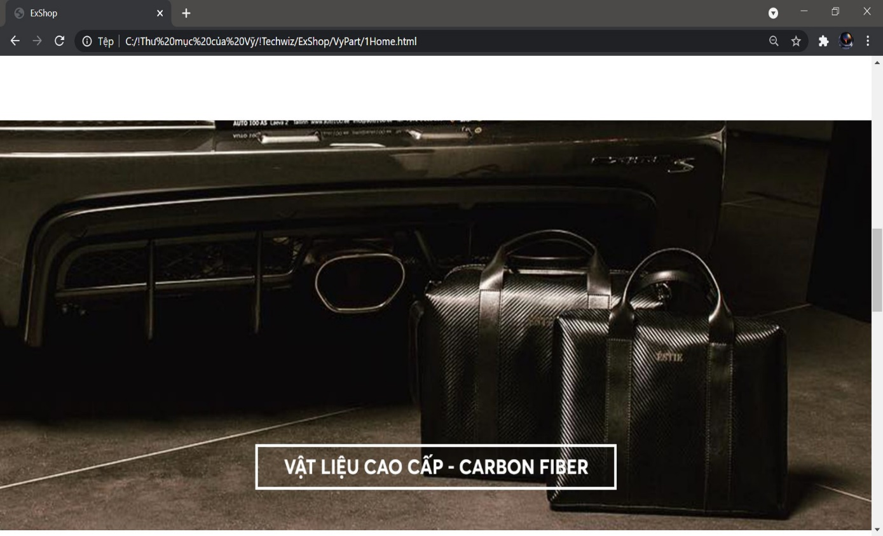

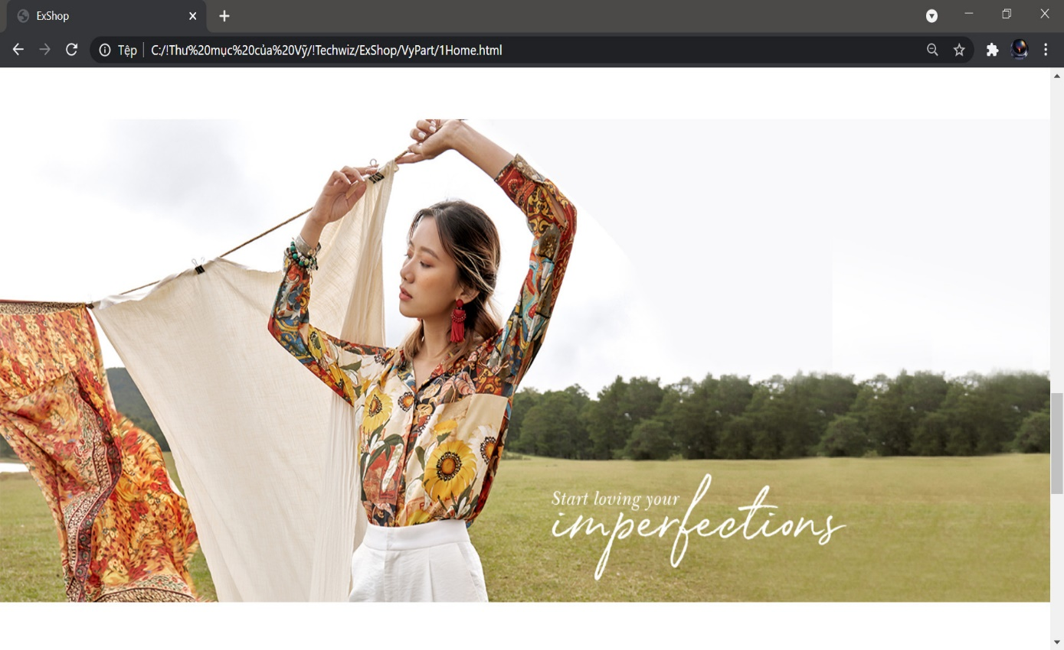



Home page contains some information as below:

* Navigated menu
* Carousel Slide, here you can see our great sale and best value on sale
* Main products.
* Electronic products.
* Household products.
* Fashion products.
* Stationery products.
* Some our great partners.
* In the footer: you can contact us directly at that address.

1. Products page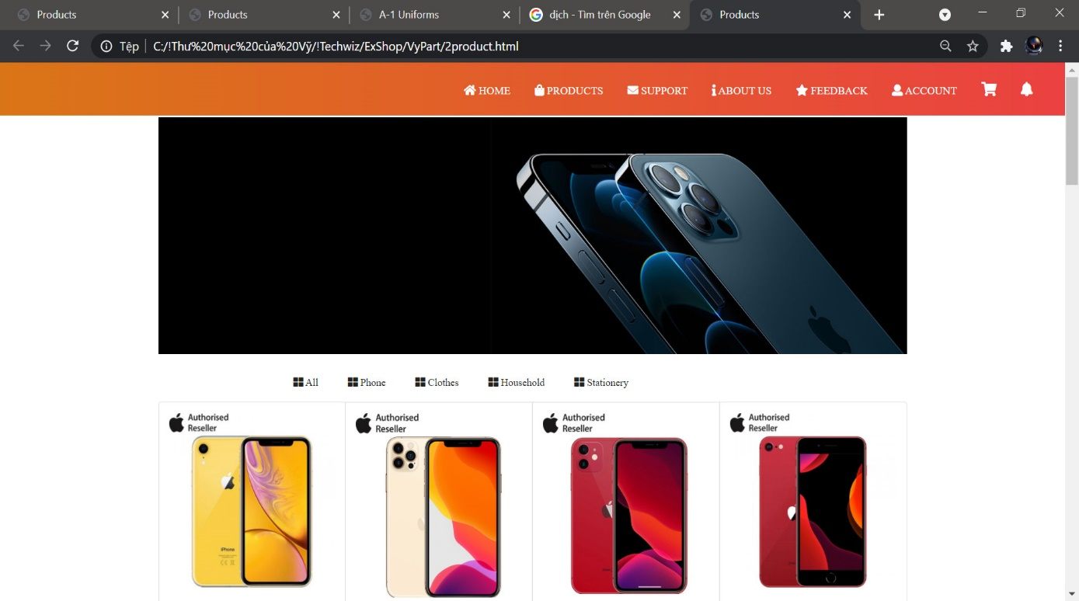

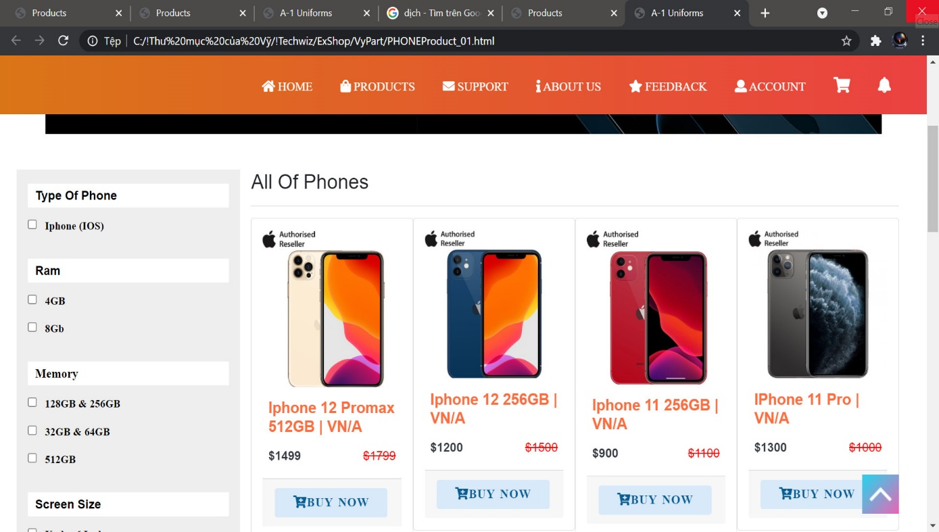

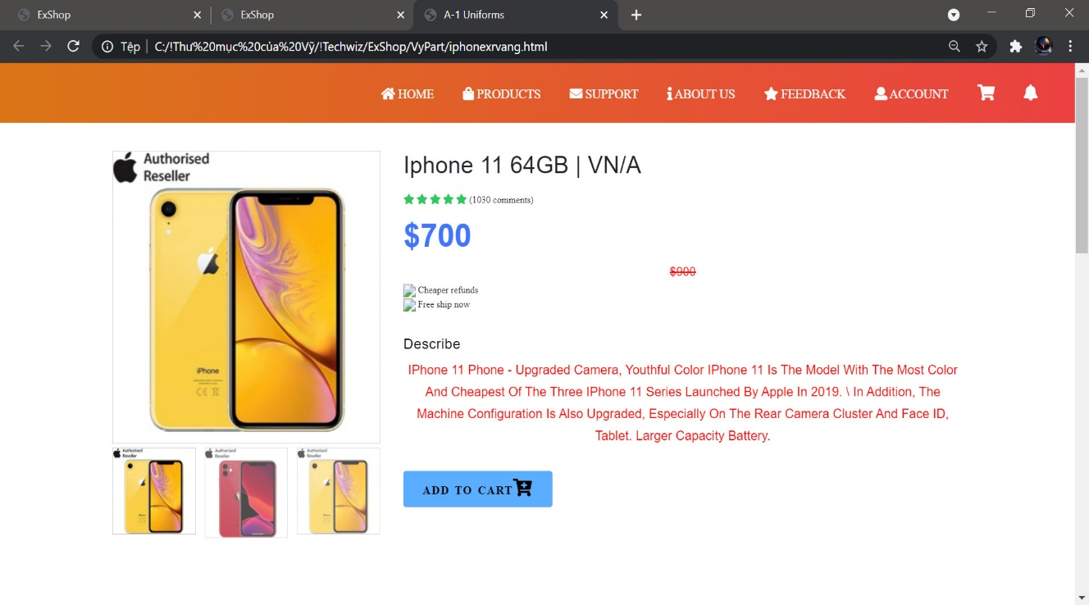

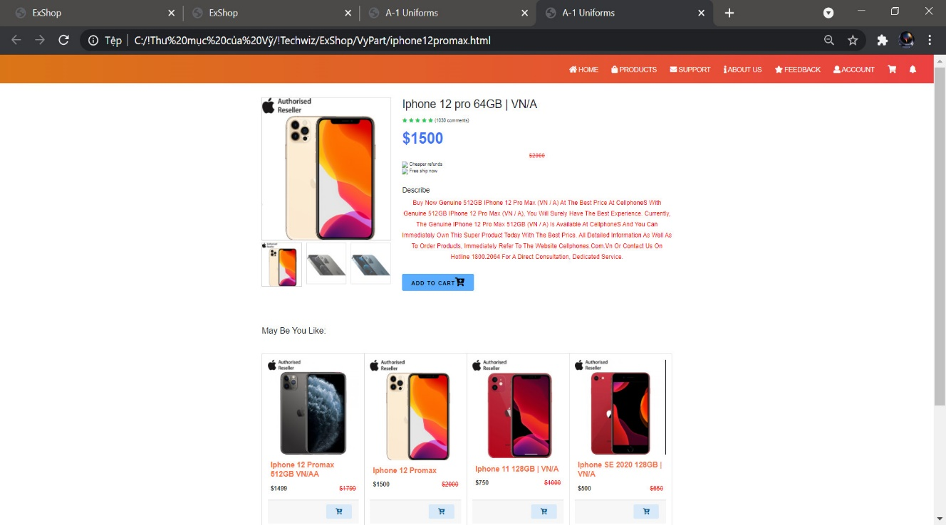

In this page, when you click the arrow button next to the word "Products", all of our products will appear:

- Navbar

- Shirt Uniforms

- See all product | see all product collections

- Product of the day

- Product’s image and an information of product

- Some products card

- Feature video

- Product’s news

- Product’s news

* In the footer: you can contact us directly at that address.

3. Search page:

In the page you can directly find the product you are looking for. If you want to find products according to your requirements, please enter a product's name in the Search box.

4. Support page

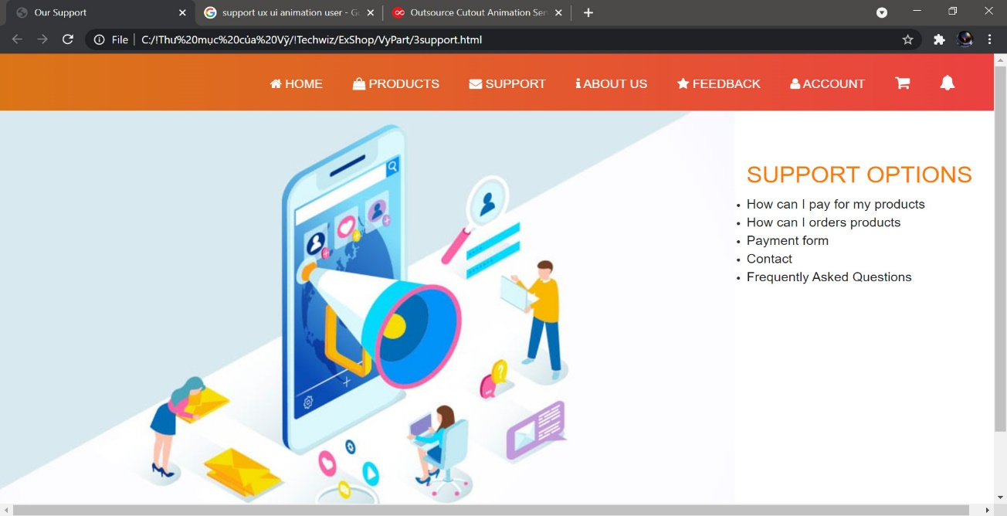

Payment Guide

If you don’t know how do you payment, please read this page, it’ll help you.

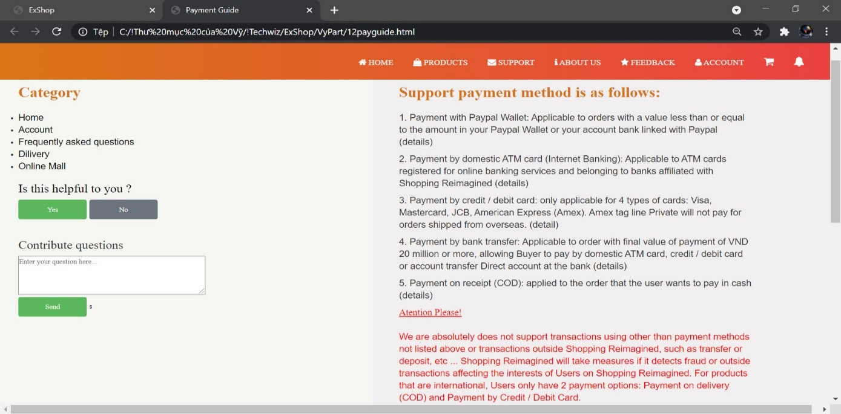

Order Guide

If you don’t know, how do you order products, please read this page, it’ll help you.

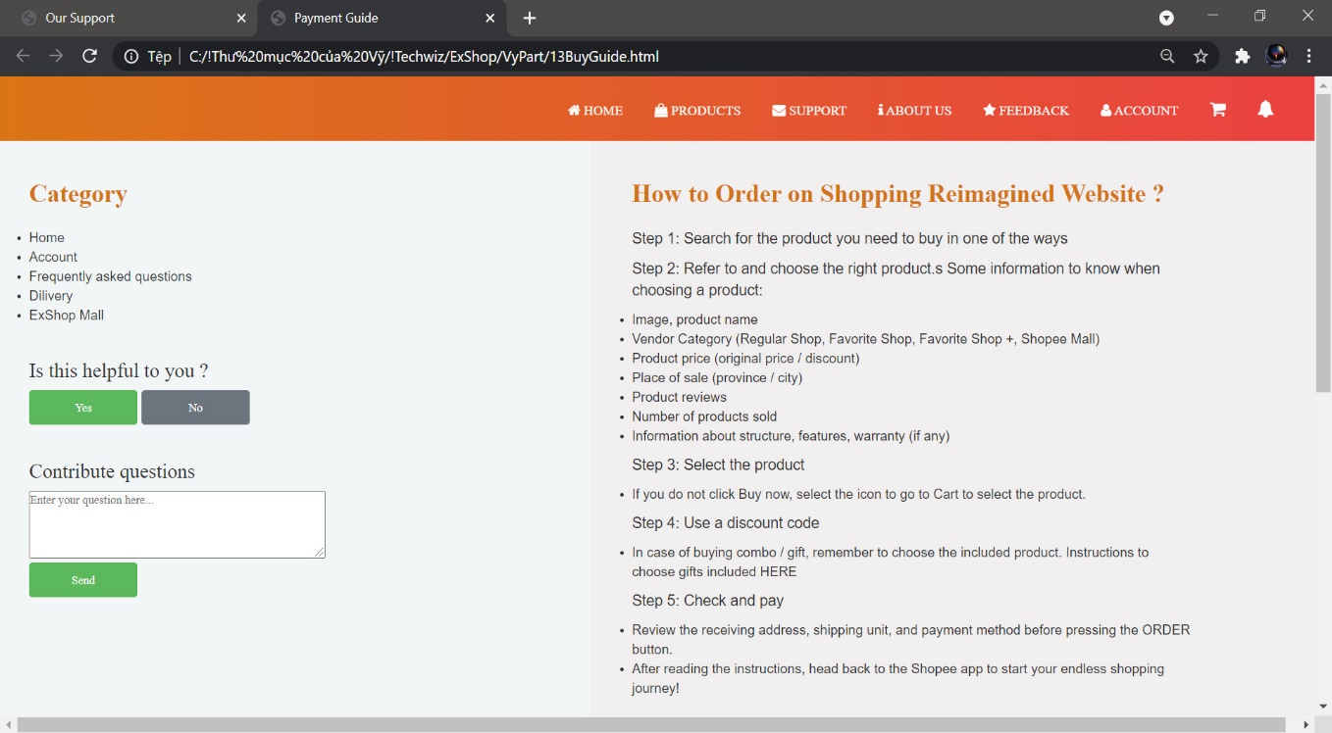

If you have any questions, please read this Question page.

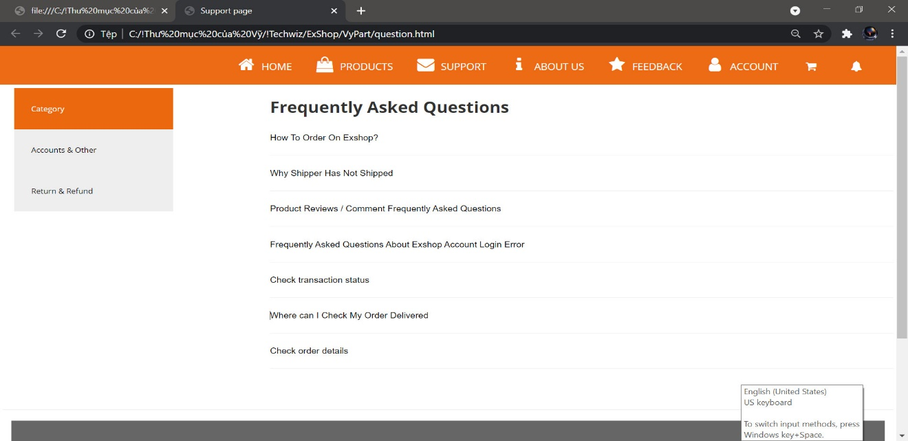

If there are no relevant questions or answers here, please select "Contact us" for more inquiries. Thanks.

5. About us page

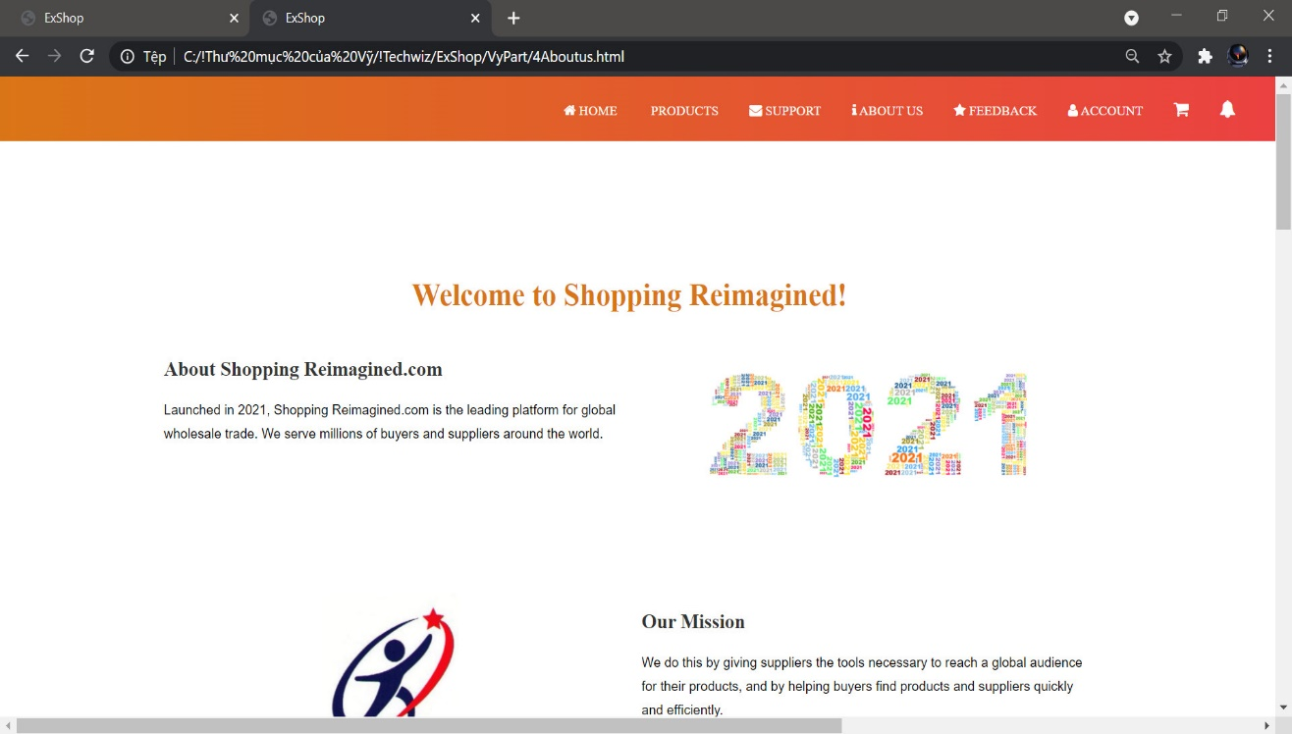

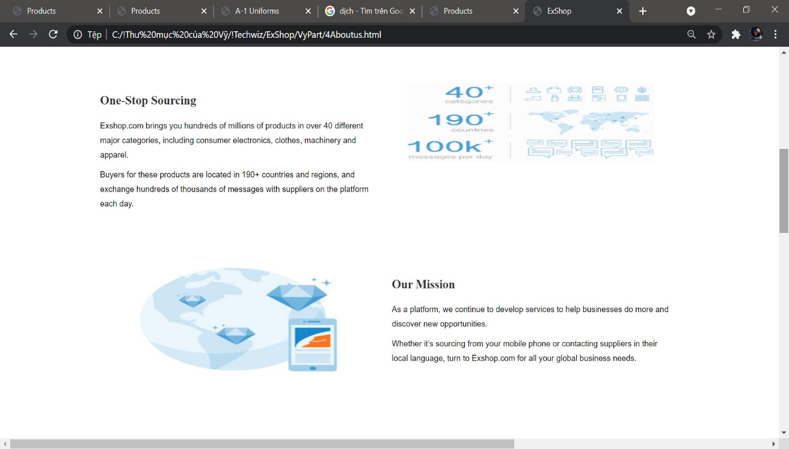

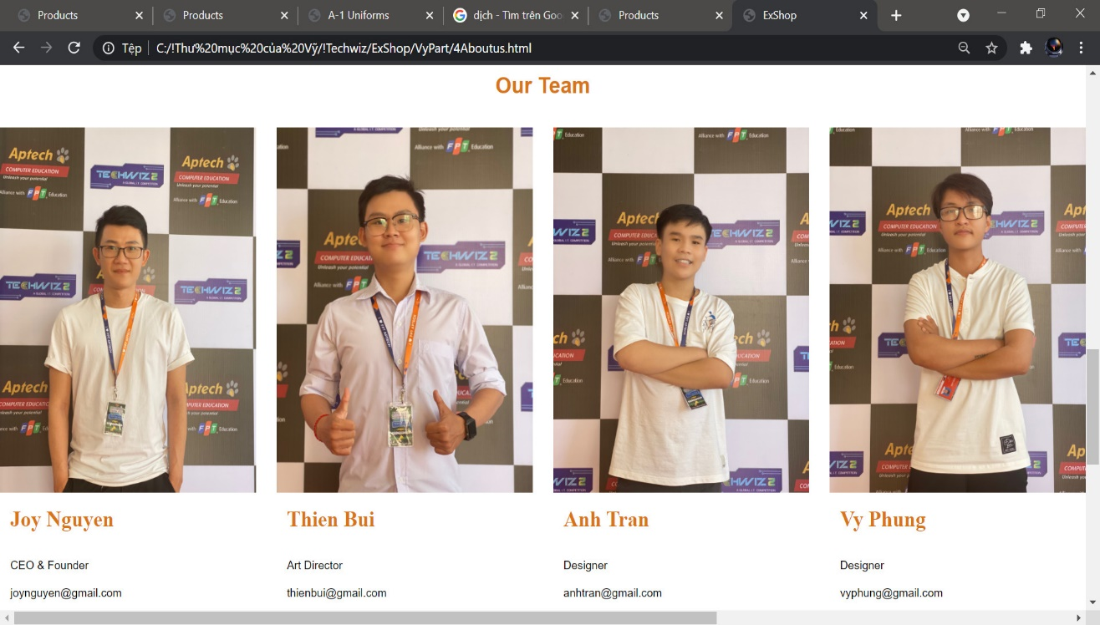

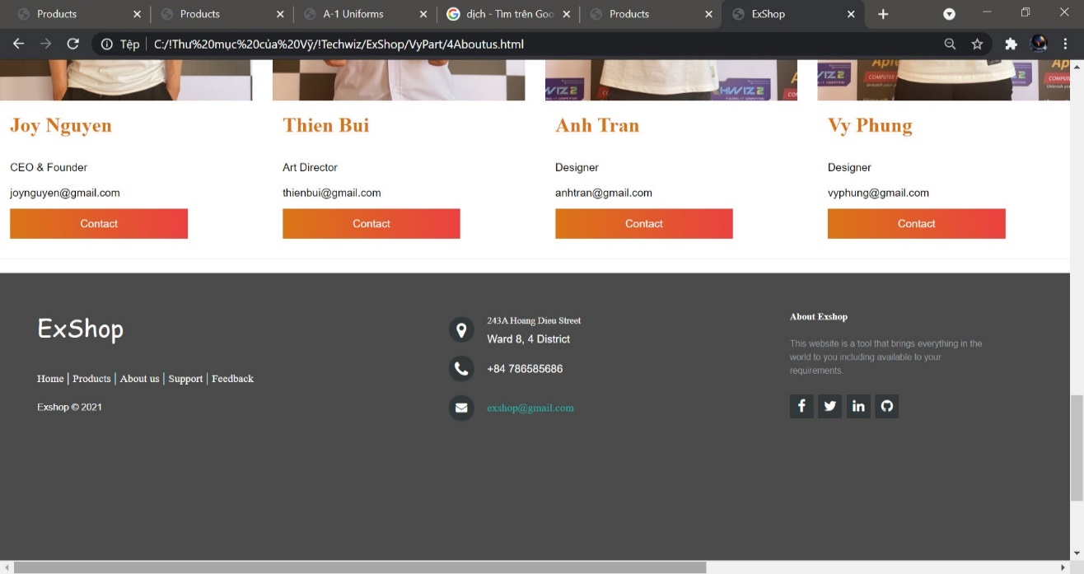

In this page, we show all information in details about the Shopping reimagined:

* Navbar.
* Something about us:

+ About Shopping Reimagined  
+Our Mission

+On topsourcing

4. Contact us



Click on it, a page will be appeared and user will have to submit all contact and content they want to tell to Shopping reimagined.

- Navbar.

- Contact form (These are required information) include:

+ Full name: fill your full name

+ Email: fill your email

+ Phone: fill your phone number

+ Title: This is the subject you need to contact us.

+ Text: This is the content you need to contact us.

- Google map

5. Feedback page

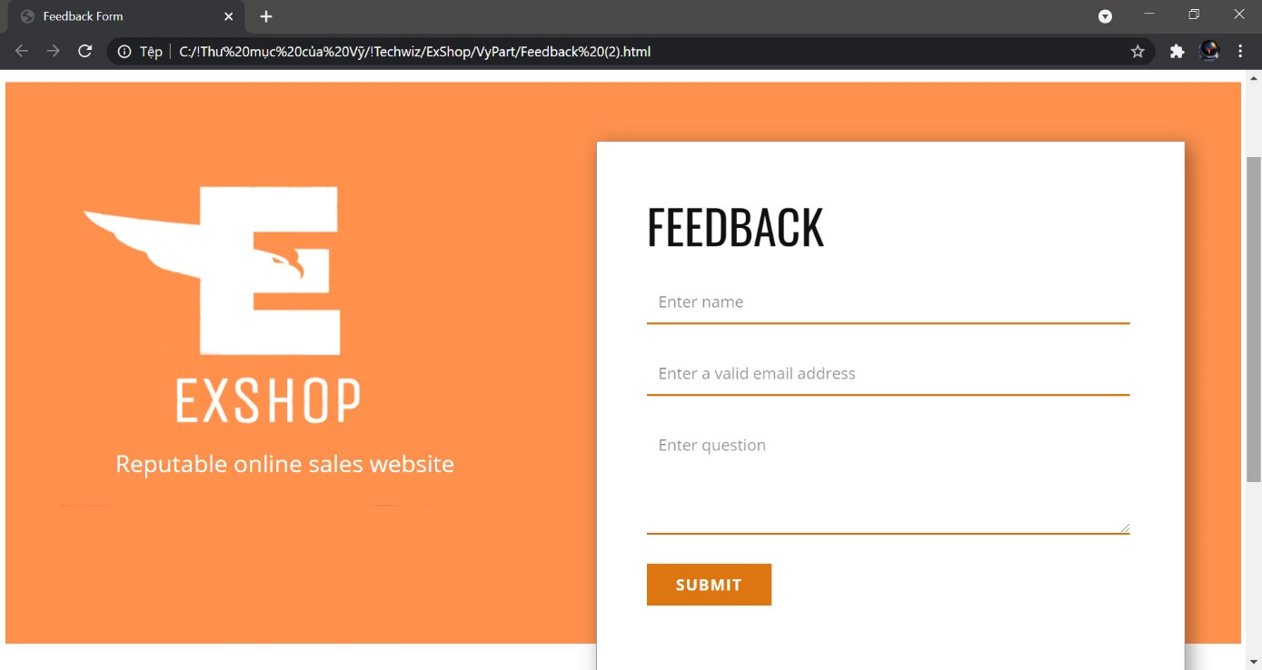This is the Feedback page of the website. In here, you can see:

-- Navbar

- Feedback form

+ Full name: fill your name

+ Email: fill your email

+ Comment/Feedback: Will be received the feedbacks or not good feedbacks about product/service in the Shopping reimagined to help we improve more.

- Google map

- In the footer: you can contact us directly at that address.

6. Register

User Registration plugin provides you with an easy way to create frontend user registration form and login form. Drag and Drop fields make ordering and creating forms extremely easy. The plugin is lightweight, extendible, and can be used to create any type of registration form.

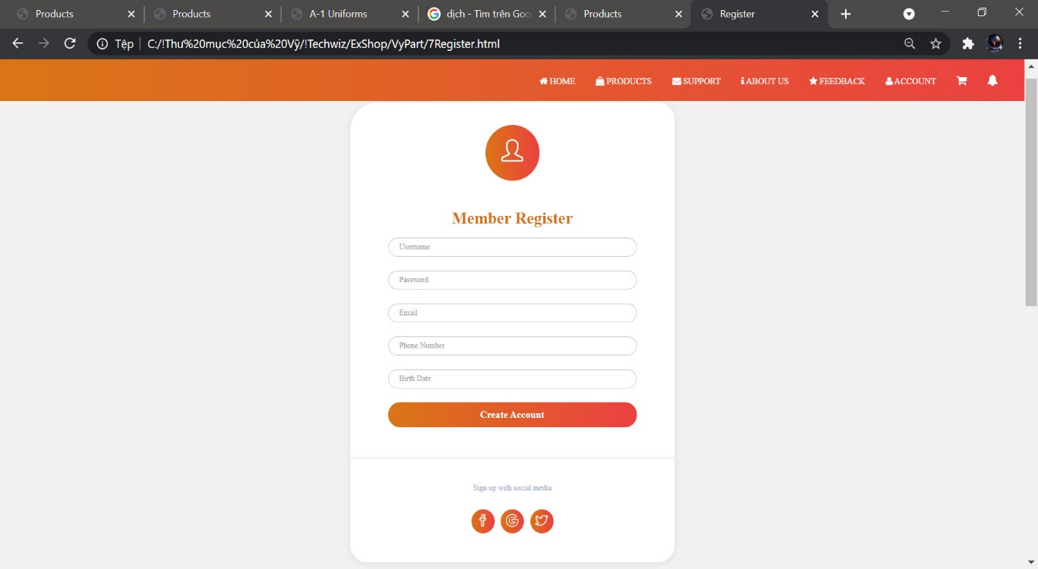

Beside registration form, the plugin also supports beautiful frontend profile account page for profile edit, password change, Log out and more. Users can visit their account page after registration and view the details they have filled and can make changes if necessary.

The registration forms are 100% mobile responsive and optimized to display on any devices.

7. Login

7.1 Login page

Every user must login to the Service Portal in order to use the functions in the portal:

7.1.1 Screen

Enter user credentials and click "Login":

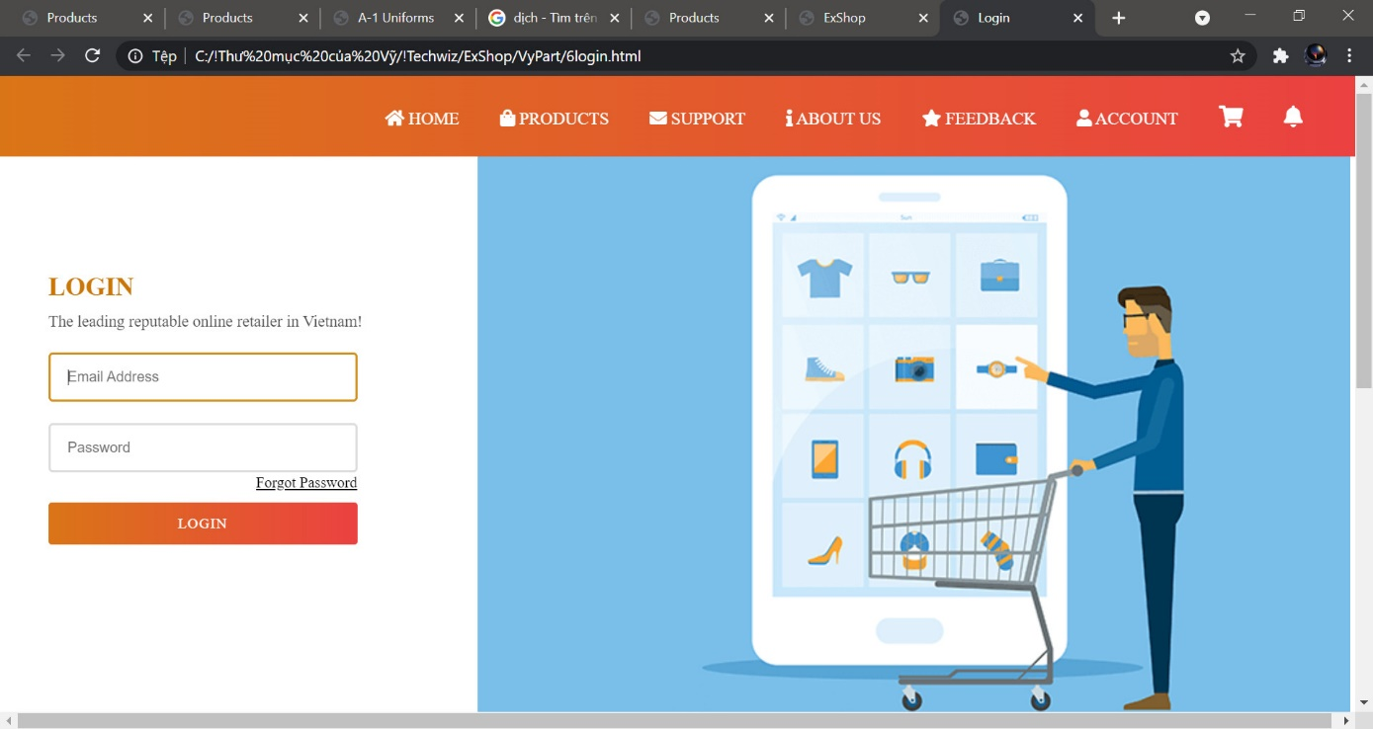

### 7.1.2. Fields

* Username: Login name (email)
* Password: Login password

7.1.3. Procedures

* To log into the system, enter your login ID in Username and login password in Password fields
* Click "Login"

### 7.1.4. Note

* You will be directed to the landing page once you have successully logged into the system.
* You will be prompted with error message when:
  + Username is blank
  + Password is blank
  + Incorrect user ID or password
* If you have forgotten your password, you may reset it by clicking "Forgot my password" You are then required to enter your registered email address and click "Reset Password" to proceed to reset your password. Also an email notification will be sent to you. Once you check your registered email and confirm your password reset action by clicking on reset password "link". It will direct you to enter your desirable new password. If all steps are followed and completed, a successful password reset confirmation will be displayed. You will then be able to enter the system again.

**Login failure page**

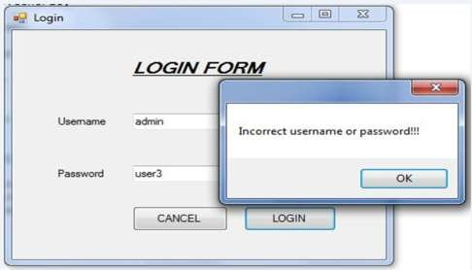

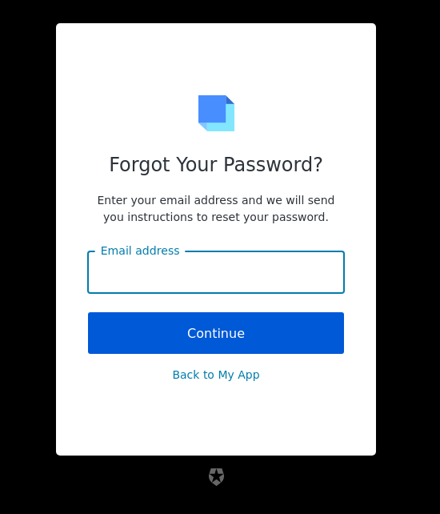

**8. Shopping Cart**

When you order the product and want to see how many products you have already ordered, go to the shopping cart icon in the navabr. Here you can view all products that you have ordered, can delete, and add product numbers. And then you can go to payment page.

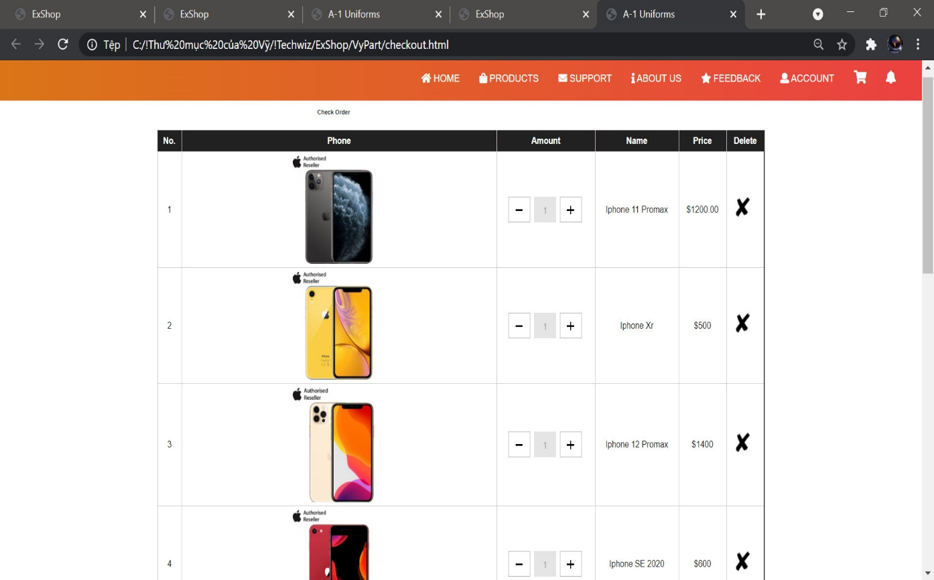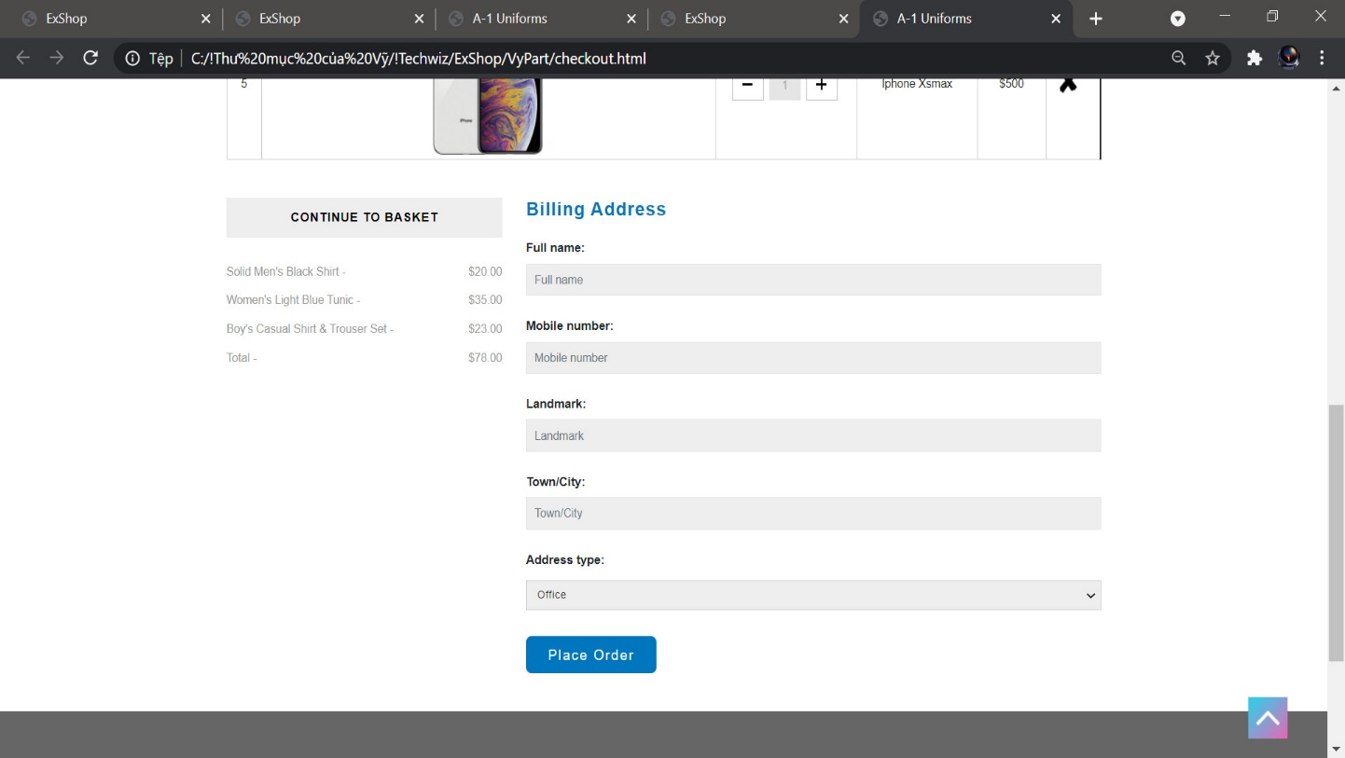

Payment page:

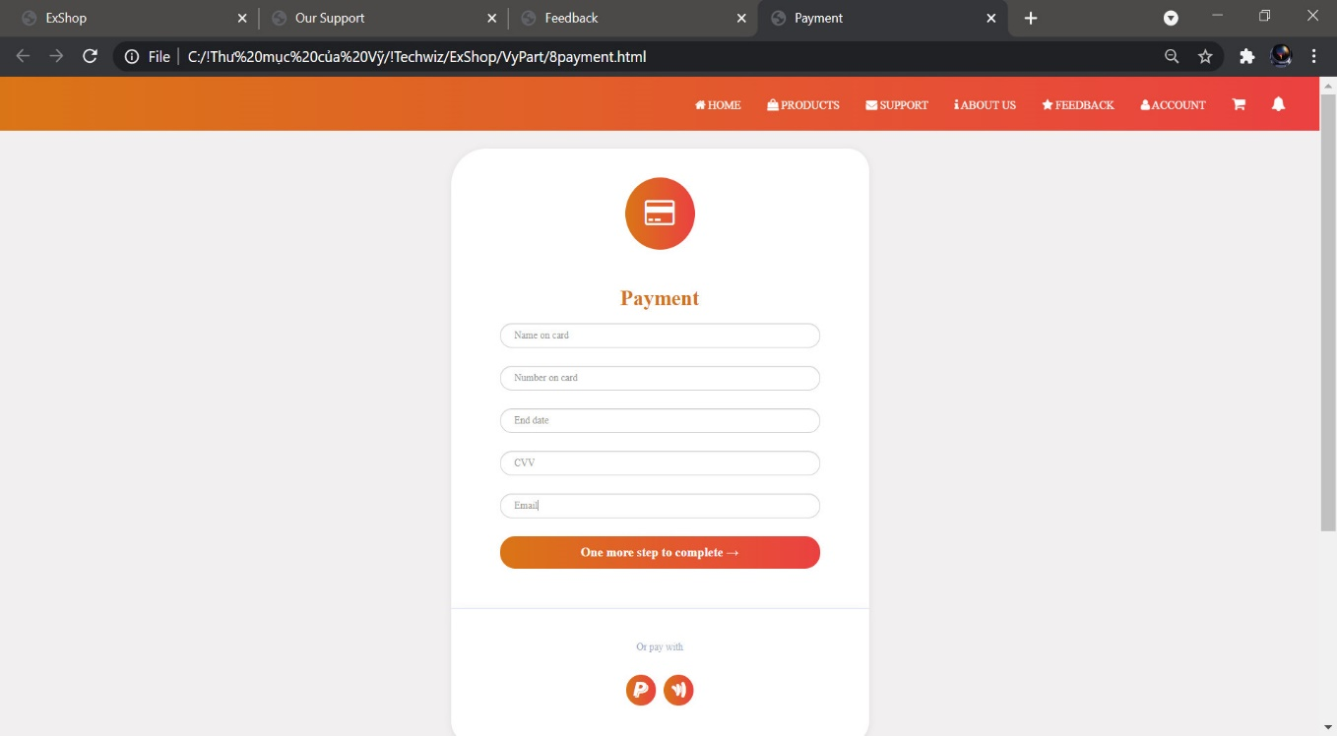

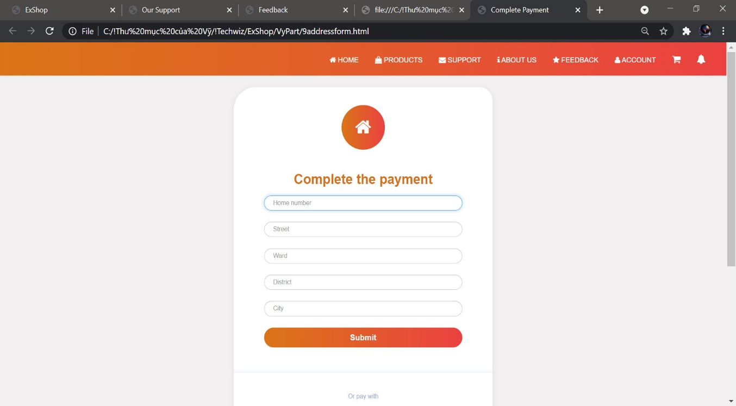

1. Hosting

The Website will be hosted on a local Web server and will be tested on all latest and popular browsers such as IE, Opera, and Chrome.

url: link source: https://github.com/Joy1402/Shopping.git

link run test: https://joy1402.github.io/Shopping/

2. Hardware requirements

The requirements on the client machine include Pentium 4 or higher processor, 1 GB or higher RAM, and a compatible browser to view the Website.